CHAPTER 1 INTRODUCTION TO THE STUDY

Background of the Study

With the widespread influence of social media come viral posts revealing gaps in knowledge regarding history. These incidents prompted people across social media to air their concerns about the country’s worsening academic crisis (Cruz, 2022; Philippine Daily Inquirer, 2022). In a report shown by PISA (2018), the Philippines ranked last in reading literacy and second to the last in mathematics as well as science. Even before the pandemic, the Philippines has struggled with keeping up academically with the rest of the world. The conditions the students are forced to subscribe to during the pandemic only made it worse (De Guzman, 2021). One subject that is bearing the brunt of the country’s worsening educational state is history.

Pinoy Big Brother, a reality TV show aired an episode where they hosted a game of question and answer that sparked criticism from viewers and non-viewers alike. When asked how the three priests martyred by the Spanish colonial government were collectively known, one housemate answered “Marjo” taking hints from the first syllables of their names: Mariano Gomez, Jose Burgos, Jacinto Zamora; while the rival housemate answered “Majoha'' when the correct answer was “Gomburza”. Netizens expressed their disappointment at their cluelessness about basic historical knowledge (Cruz, 2022). The episode made headlines, the two contestants were the prime subject of internet memes and ridicule (Bellina, 2022), and as it caught the attention of the education secretary (Magsambol, 2022), it sparked discussions about who was exactly to be blamed and about the outrage for our worsening education system (Philippine Daily Inquirer, 2022). This, however, was not the first time such an incident occurred.

In 2015, with the release of the movie ‘Heneral Luna’, a certain social media post made rounds on the internet which later blew up with the admission of one of the movie’s actors, Epy Quizon, that a group of college students asked him why his character Apolinario Mabini was seated the entire time. Presiding President Benigno Aquino III expressed dismay at the news which led him to call upon the attention of the Education Secretary to correct this belief (Sabillo, 2015). In 2020, a social media influencer provoked the ire of netizens after a video of her failing to recognize Jose Rizal in a ‘Guess Who’ challenge went viral (Nelz, 2020). Incidents such as these have brought progressive groups and associations to come forward and call upon the return of Philippine History in our current educational curriculum as it was removed as a dedicated course in high school in 2014 (Ignacio, 2019; Begas, 2022). However, government representatives responded by saying that Philippine History is already integrated into other Araling Panlipunan (AP) subjects such as Asian History.

According to a book entitled K to 12 in Southeast Asia (2012), the amount of time allot

ted for teaching Social Studies (Araling Panlipunan) in the Philippines, under the term Makabayan, is disproportionately high compared with those in other countries (300 minutes per week in grades 1 to 3)”. It is strange then that with so much time devoted to Makabayan, people are still ignorant of basic Philippine historical facts. When these factors are considered, it is clear that our current educational curriculum is flawed and these subjects are not taught the way they should have been taught especially now that people are more immersed in the internet due to the pandemic, as teachers are now competing with social media as a source of information (Magsambol, 2022). It is no wonder then that people believe that Jose Rizal is the father of Hitler or that he is the infamous Jack, the Ripper (Ocampo, 1990).

Thus, there is a need to develop an alternative means of learning that could promote it in ways traditional learning methods cannot, especially in the form of a visual novel; a form of interactive medium that can be used to teach learners using a narrative multi-branching structure. For the past several years, studies on utilizing visual novels as an aid to learning have increased (Agusalim, 2015; Prasetyo & Kuswardani, 2021; Lochman, 2020). To further explore its potential, a study directed at its capacity to assist people in learning was conducted by the researchers to determine whether it was a medium that could be used to promote learning.

Objectives of the Study

This study sought to develop a historical visual novel that could promote learning through a positive game experience.

Specifically, the study aimed to:

1. Create a visual novel with Jose Rizal as the main subject;
2. Develop a visual novel based on historical facts; and,
3. Evaluate the visual novel through usability evaluation.

Significance of the Study

The results of the study may be beneficial to the following:

* For the Students, this study will help them gain a positive learning experience that is accessible and easy to understand through an enjoyable form of media.
* For the Faculty, this study will help them provide alternative material that can support students and encourage them to delve deeper into the subject.
* For Future Researchers, they may use this study to gain knowledge on making their research paper and for their future research and inspire them to conduct research based on the theories and methodology employed in the research.

Definition of Terms

For better understanding, the following terms were defined conceptually and operationally:

*Clip Studio Paint* -- Celsys’ Clip Studio Paint is an all-in-one paint tool for artists who enjoy creating hand-drawn illustrations within their graphic design, manga/comics, animation, or other digital art projects. Created with artists in mind, from beginners to the most seasoned professionals, the program offers some of the best drawing tools available for a natural and enjoyable drawing experience – over 6 million artists worldwide take advantage of Clip Studio Paint’s powerful and easy-to-use features on a wide variety of personal and professional projects (Sarto, 2019).

In this study, it refers to the program used to make the Character Sprites and Background Design of the game.

*Cognitive Theory of Multimedia Learning* -- Cognitive Multimedia Theory describes the cognitive processes in multimedia learning that helps students retain information more effectively. Its main aspect is the multimedia principle that states that students learn better when more than one channel is implemented such as integrating pictorial and verbal representations and prior knowledge (Mayer, 2014).

In this study, it refers to the learning process used in the game.

*José Rizal*–José Rizal, in full José Protasio Rizal Mercado y Alonso Realonda, (born June 19, 1861, Calamba, Philippines—died December 30, 1896, Manila), was a patriot, physician, and man of letters who was an inspiration to the Philippine nationalist movement (The Editors of Encyclopedia Britannica, 2021).

In this study, he is the main character of the game.

*Krita* – Krita is a painting software that is used by both professionals and amateur artists alike. It is a free and open-source platform that offers an extensive amount of features for image manipulation and for creating digital art. Krita's large library of tools makes it possible to perform advanced and conventional drawing techniques. Its powerful capabilities make it attractive to 3D artists, illustrators, and concept designers (Tolcheva, 2021).

In this study, it refers to the program used to make the Character Sprites and Background Design of the game.

*Python*– Python is a computer programming language often used to build websites and software, automate tasks, and conduct data analysis. Python is a general-purpose language, meaning it can be used to create a variety of different programs and isn’t specialized for any specific problems. This versatility, along with its beginner-friendliness, has made it one of the most-used programming languages today (Coursera, 2021).

In this study, it refers to the programming language used to make the visual novel game.

*Ren’Py Visual Novel* – The Ren'Py Visual Novel Engine is a free Game Maker software geared specifically towards developing Visual Novels, but flexible enough to accommodate games in any narrative-heavy genre.

In this study, it refers to the program used to make the visual novel game.

*Visual Novel* – A visual novel is a video game genre that tells an interactive story primarily through text. They usually feature static character models and locations, and while they might have some animated cutscenes, these are typically short (if present at all). While most video games feature some amount of text, visual novels are unique in that they more closely resemble a written work. Instead of telling major parts of the story through gameplay, cutscenes, or context clues, you read a lot of dialogue and other text to advance through the narrative (Stegner, 2021).

In this study, it refers to the genre of video game used in the study.

Delimitation of the Study

This study only focused on visual novels as a tool to help students gain a positive learning experience. This study was conducted on sixty-four (64) Information and Communications Technology students in a University. The game focused on Jose Rizal and it covered his love life from ages 16 to 19. It also utilized the Ren’py engine in creating the said visual novel. Other genres of educational games were beyond the scope of this study.

CHAPTER 2 REVIEW OF RELATED STUDIES

## Review of Existing and Related Studies

*Visual Novel*

Visual Novels, or “VN”, is a genre of interactive multimedia originating from Japan that utilizes a multi-branching narrative and the use of player interaction to progress the plot (Cavallaro, 2010).

It is similar in many ways to a novel but with the addition of character sprites, sounds, HUD (Heads Up Display), and CGI cutscenes to further enhance the player’s immersion within the story.

Visual novels are typically commercialized for entertainment whether as an adaptation of an existing property or as a franchise in itself (i.e. The Fate Series by Type MOON). However, there have been attempts to integrate it into education such as in the study conducted by Salazar, Nakajima, and Alaxendrova (2013) where they listed the steps in creating a visual novel specifically for educational purposes. Some of the more important steps they listed were:

1. Determining a topic to teach.

2. Creating characters and a general plot.

3. Test stories and characters with the target audience.

4. Construct conflict and dramatic tension points for the reader.

5. Decide on the implementation of the mechanics of the VN, such as the art direction and UI/UX design.

6. Choose conversation patterns such as dialogue options and sound design.

7. Track user progress and point counting method.

The methodology that they used for this was in teaching college-aged students about normal eating habits and nutrition. This process managed to teach four (4) out of five (5) topics on average and motivated half of the students to put the knowledge into practice.

In another study conducted in 2015 (Agusalim), the researcher developed a visual novel that adopted the English curriculum of their university to motivate and encourage independent learning among Indonesian students in the Distance Education Program. One problem the research raised was the distance learning setup which was deemed ineffective when it came to language learning that required having real-time conversations with people.

The researcher developed the visual novel as a tool to help students learn a language by simulating real-world English conversations with eye-catching graphics that would help pique their interest. The results of the study indicated that the visual novel was appropriate as it was assessed to be 94.5% attractive and useful by a board of validators.

Similarly, in another study published in 2021 (Kuswardani & Prasetyo), the researchers developed a visual novel to aid high school students in studying English, mainly their reading ability.

The research raised similar problems with the distance learning setup, this time in the context of the pandemic, and English being a required subject in school as a product of globalization. The study also stated that since classes were conducted online, students were able to spend more time on their smartphones, hence, the need to utilize media to aid their learning.

The results showed that the visual novel met the requirements of effective media and was suitable and acceptable as a means of learning English. Besides using visual novels to help students learn English, another pattern observed was visual novels being used as an alternative to remote learning setup.

*Theory of Multimedia Learning*

Cognitive Multimedia Theory describes the cognitive processes in multimedia learning that help students retain information more effectively. Its main aspect is the multimedia principle that states that students learn better when more than one channel is implemented such as integrating pictorial and verbal representations and prior knowledge (Mayer, 2014).

The second principle is that humans have a limited capacity to process information simultaneously as they create mental representations from information sources (Mayer, 1997). When information is integrated with existing knowledge, the information absorbed from two or more channels can make the process of transferring knowledge successful (Mayer, 2002).

Multimedia Theory has also been used in education to increase learning efficiency in students. An example of this would be a study conducted by Ercan (2014) where the use of multimedia learning materials allowed for a significant difference between the post-test scores of the experimental and control groups. Students scored higher in academic achievement and their attitude toward science courses improved.

*Education with Video Games*

An evaluation study of an Intelligent Tutoring System (ITS) showed that educational virtual reality games motivated students to retain information and even improved the educational effects. Another finding of this study was that educational effectiveness was higher for students who performed poorly in the subject before playing the game (Virvou et al., 2005).

The benefit of video game learning is that games allow the player to continuously monitor and control progress through feedback and to develop cognitive, motor, and spatial skills. It also improves collaboration between players by allowing them to exchange information and learn from each other (Simkova, 2013).

This is further supported by a paper written by Anastiadis, et al. (2018) on digital Game-based learning. They discussed in their study the merits of “serious games”. Some of these were a progressive learning experience, a positive competitive environment, social-emotional growth, and soft skills development. Within the context of visual novels, the gameplay was entirely focused on interacting with fictional characters through dialogue. More often than not, it would require the player to use their better judgment and soft skills to navigate and solve complex issues.

CHAPTER 3 RESEARCH DESIGN AND METHODOLOGY

Description of the Proposed Study

This research focused on developing a historical visual novel that could promote learning through a positive game experience. A visual novel was created and written by the researchers and was also published by the proponents. It was a visual novel where it had a “flag marker system” that would measure and remember the player’s choice in the game which would determine the final outcome. The researchers utilized Clip Studio Paint and Krita to create character sprites, background designs, and the CGI cutscenes of the game. The game was made through the Ren’Py Engine by encoding all character sprites, background designs, CGI’s, and dialogues based on the specified plot. This study may be beneficial to students in their education.

Methods and Proposed Enhancements

Visual Novels are frameworks that are used to make a narrative kind of story. In Visual Novel games, the player takes on the role of a character in the story, either in first person or third person, and interacts with the characters through dialogue. Players can affect the flow of the story by making choices at various plot points throughout the game as they journey through the story. If the game has several outcomes, these choices may have an impact on the story's final fate.

One of the uniqueness of this study is the game-based learning through cognitive processes in multimedia learning that helps students retain information more effectively. As discussed in the related articles, it has an exquisite impact on learning and education. Hence, the researchers invest a lot of effort to make the visuals interesting.

Another key aspect and enhancement of this study among previously published studies is the visual novel's availability offline. The visual novel does not require an internet connection and can be accessed even without internet availability which makes the demand for the resources lower.

Components and Design

*System Architecture*

For the development of our Visual Novel, a complete Visual Novel consisted of the following basic components, as shown in Figure 1.

1. Users: They were the beneficiaries that experienced the Visual Novel.

2. Flag Marker System: It was a method that would control the user's story route based on the user’s choices and various event markers that would be generated.

3. Ren’Py Visual Novel Engine: It served as the primary framework for the study. To create the Visual Novel, the software's inbuilt features were utilized.

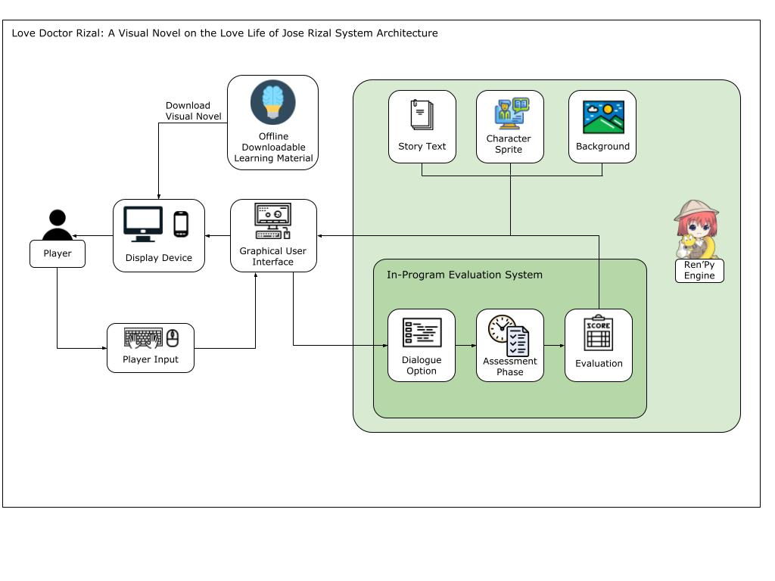

**Figure 1**. System Architecture of the Proposed Game

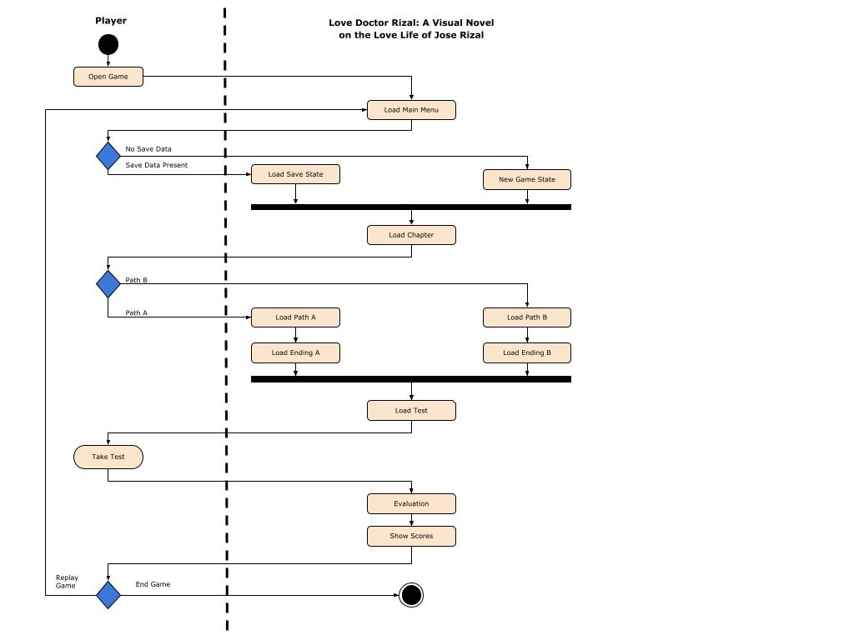

**Figure 2.** Activity Diagram

The activity diagram shown in figure 2 displays the interactions between the user and the Visual Novel.

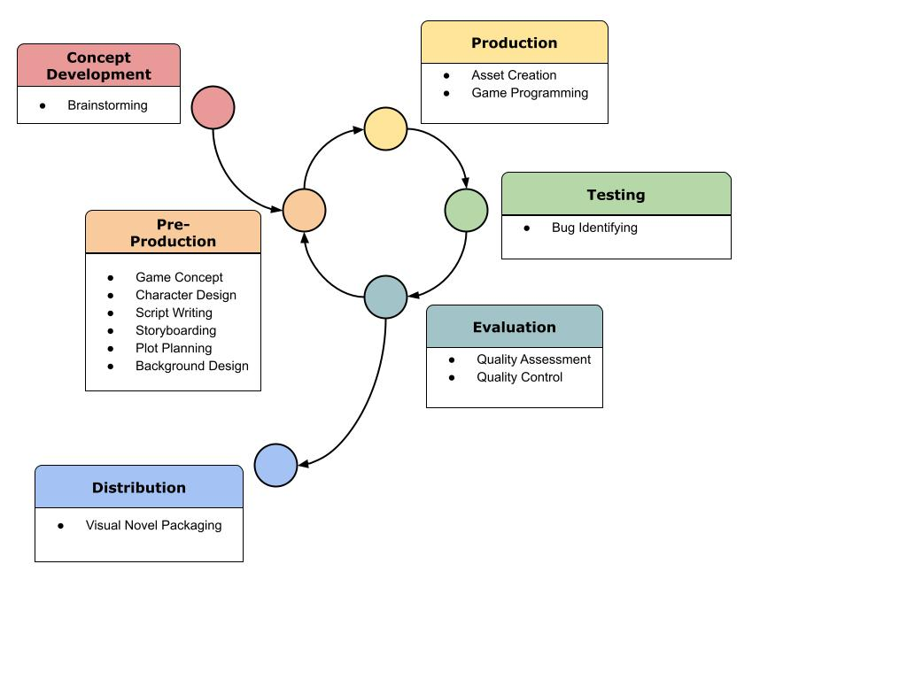

**Figure 3.** Game Development Life Cycle

The Iterative Model for the Game Development Life Cycle was used in this study. The Iterative Model Game Development Life Cycle improved on prior produced versions of the game's evaluations. The iterative model allowed for rapid prototyping and evaluation of prototypes. It also reduced any risk associated with long-term choices taken throughout the development process. It was beneficial to this Study because of its ability to make improvements based on input from previous studies.

CHAPTER 4 RESULTS AND DISCUSSION

Implementation

Since the study was based on history, the researchers gathered as many references as possible from photographs to books to historical movies and documentaries to ensure an accurate depiction of relevant historical events. For the character design, the researchers decided to take creative freedom for aesthetic purposes and to add more personality to the characters while still remaining faithful to the original fashion of that time.

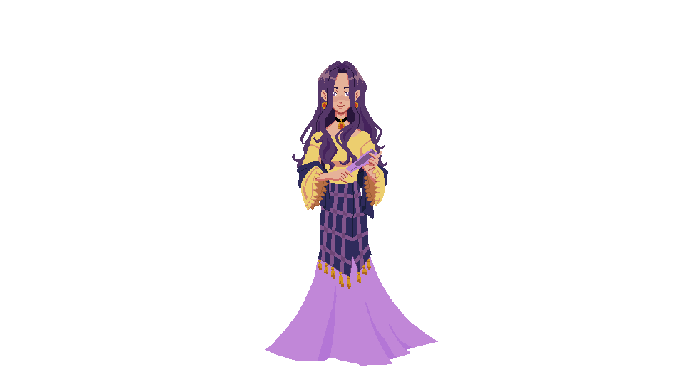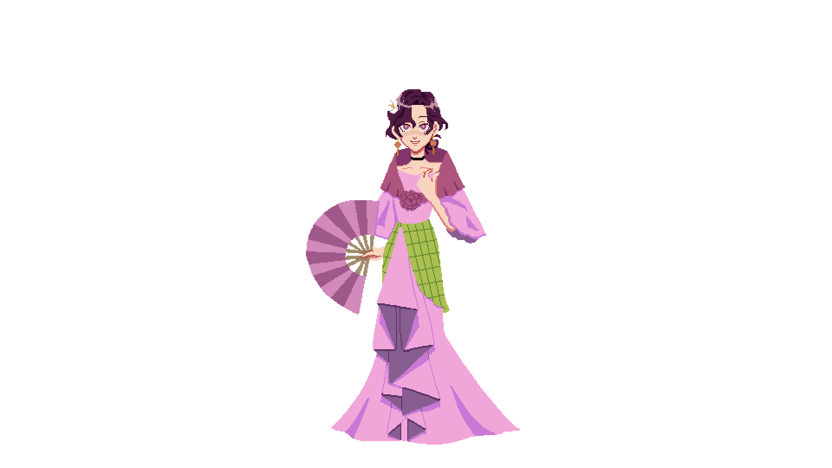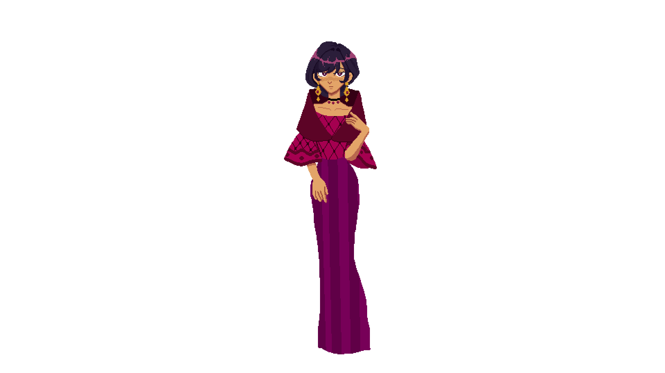

**Figure 4.** Character Design of Segunda Katigbak, Leonor Rivera and Leonor Valenzuela

For the script, the important and pivotal events were based on articles, documentaries, and books such as those by historians Ambeth Ocampo and Leon Ma. Guerrero. The researchers took creative freedom to fill in the blank parts of the story and added details to events that were vague. Additional scenes not backed by history were added to push the story forward. Experts were asked to validate the script. For the background design, the researchers compiled photographs of the places and painted over the said references. Creative freedom was employed in places where no photographs were available and were not significant enough to distort history.

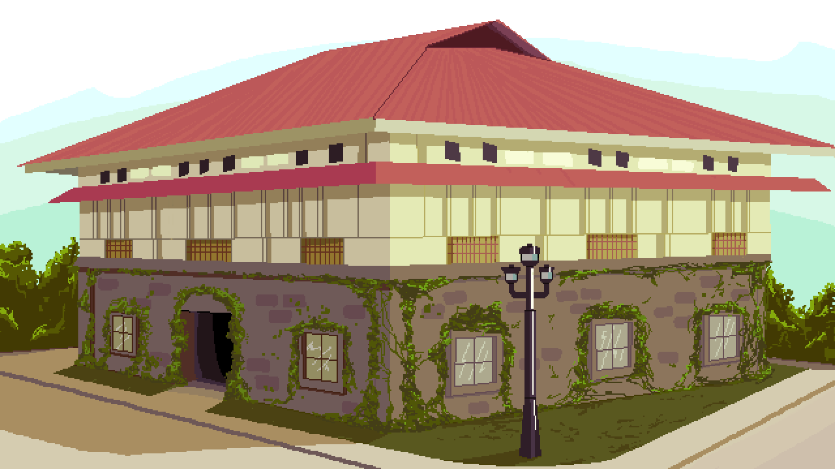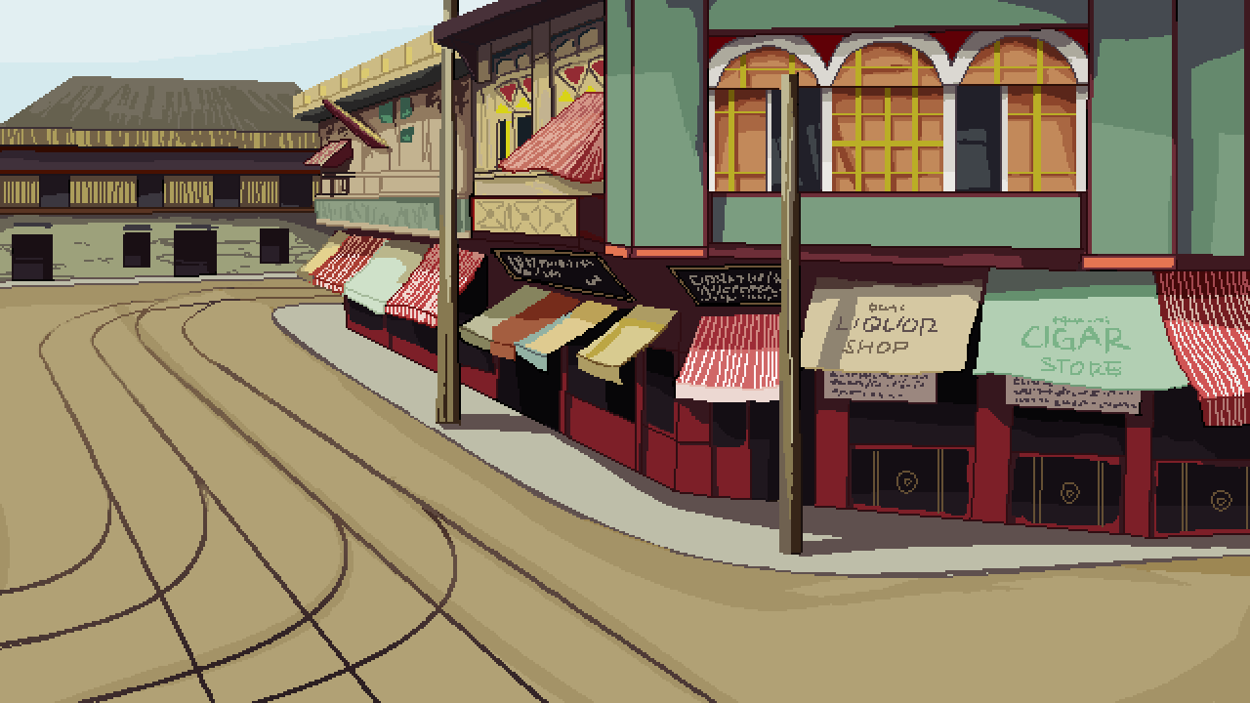

**Figure 5.** Background Design of a

Bahay na Bato and Escolta

Krita and Clip Studio Paint were used to create the character designs. The designs were drawn digitally and served as a base to be painted over using a pixelated brush to achieve desired aesthetic results. The sprites were then exported to .png at 960 X 540 resolution and then imported into a pixel art scaler and enlarged to 1920 X 1080. The same process was utilized in the making of the background except that it was exported on 640 X 360 resolution and then enlarged to 1280 X 720 to fit the standard screen size used on Ren’Py. To reduce the file size of the game, the researchers were advised to convert all .pngs into .webp.

The story script was first converted into a game dialogue tree using Twine, a free tool that game developers use to create branching paths within the story. The HTML file was then ported into the chosen game engine to create the dialogue system.

The engine used to make the game, Ren'py, used its own coding language based on Python and Javascript using the code editor Atom. Everything from the appearance of sprites to the programming of the flag marker system was done in this software.

In Ren'Py, the game performed checks using if-else statements in branching dialogue paths set to TRUE or FALSE. The result of these checks would tell the engine which outcome to show to the player. These statements were known in the engine as “flag markers”

In order to maintain the accuracy of chronological historical events, the flag marker system was only implemented for Part Two of the game.

The way that the flag markers worked was that Leonor River and Leonor Valenzuela were each given a variable meant to represent the number of “affection” points they had towards the player– which was determined by the choices the player made in the dialogue. At the end of the story, these variables were called on again and if one was higher than the other it set the condition of it to TRUE or FALSE. If Valenzuela had higher points than Rivera, then it would show the Valenzuela ending and vice versa. If the player chose a girl but had more points with the other, then the HERO ending would be shown to the player.

This would allow for meaningful choices to be made that visibly affect the narrative experience the player would have.

The researchers tested the application through playtesting.

For the playtesting, the researchers asked avid and casual gamers to test the game and recorded their comments and feedback such as gameplay, UI, enjoyability, and clarity. The testers played through the game with the expectation that it would perform as initially planned with scenes playing out with the branching structure if the buttons are working, if the text size is appropriate, and reported if the game adapted to their screen size. The testers also recorded their feedback on the game. Issues were noted and then brought to the development team to be resolved.

Results, Interpretation, and Analysis

To evaluate the visual novel, sixty-four (64) Information and Communications Technology students from a University participated through convenience sampling.

In order to find out the sample size, the researchers determined the population and utilized a sample size calculator with a confidence level of 90% and a margin of error of 10%.

To measure the positive gaming experience, the researchers utilized a usability evaluation questionnaire taken from a study conducted by Scepanovic, Vujicic, Matijevic, and Radunovic (2015). The researchers dispersed a google form containing the consent form, the link to the game as well as the questionnaire. Respondents were required to play the game before answering the questionnaire.

To find out the results of the usability evaluation, the researchers used the Likert scale to measure the respondent’s attitudes toward the game.

The Likert scale contained five responses assigned with a numerical value namely: Strongly Disagree (1), Disagree (2), Neutral (3), Agree (4), and Strongly Agree (5); which would be used to measure the attitude under investigation.

To get the mean scores as well as the standard deviation, the data gathered from the usability evaluation were analyzed using SPSS and interpreted using the 5-point Likert scale scoring range.

**Table 1**

5-point Likert scale scoring range

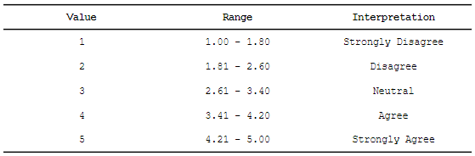

System Evaluation Results

The usability evaluation was based on a study conducted by Scepanovic, Vujicic, Matijevic, and Radunovic (2015) about Game-Based Mobile Learning - Application Development and Evaluation. The usability evaluation was divided into four components namely: Game Usability Components, Mobility Components, Game Play Components, and Learning Content Components.

The usability evaluation results were measured using the Likert scale range interpretation.

**Table 2**

Results of the Game Usability Components

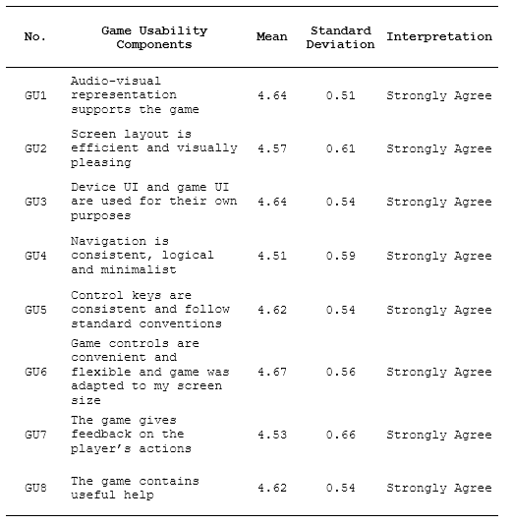

For the Game Usability Components, every question garnered a “Strongly Agree” interpretation with GU6 having the highest mean score of 4.67, with the statement “Game controls are convenient and flexible and game was adapted to my screen size” and GU4 with the lowest mean score of 4.51 with the statement “Navigation is consistent, logical and minimalist”.

**Table 3**

Results of the Mobility Components

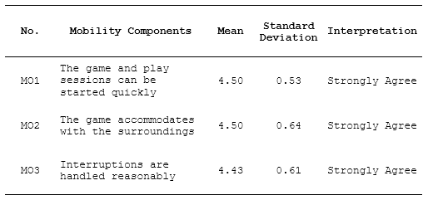

For the Mobility Components, all questions garnered a “Strongly Agree” interpretation with both MO1 and MO2 exhibiting the highest mean score rating of 4.50 with the statements “The game and play sessions can be started quickly” and “The game accommodates with the surroundings” while MO3 had the lowest mean score of 4.43 with the statement “Interruptions are handled reasonably”.

**Table 4**

Results of Game Play Components

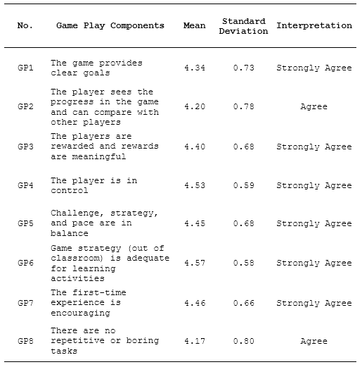

For the Game Play Components, the questions garnered “Strongly Agree” and “Agree” with GP6 having the highest mean score of 4.57 with the statement “Game strategy (out of the classroom) is adequate for learning activities” while GP8 had the lowest mean score of 4.17 with the statement “There are no repetitive or boring tasks”. This was attributed to the fact that visual novels “feature a very strong emphasis on a text-based story over gameplay, to the degree that most of the game was simply the player pressing a button to advance the text (TVTropes, n.d.)”.

**Table 5**

Results of Learning Content Components

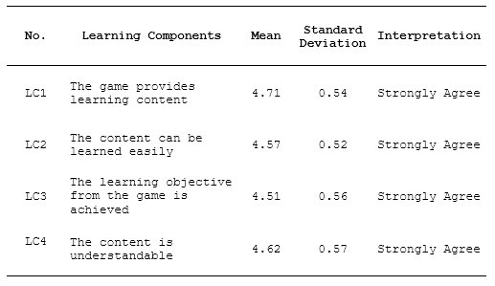

For the Learning Content Components, all questions garnered a “Strongly Agree” interpretation with LC1 having the highest mean score of 4.71 with the statement “The game provides learning content”. On the other hand, LC3 had the lowest mean score of 4.51 with the statement “The learning objective from the game is achieved”.

**Table 6**

Results of the Components

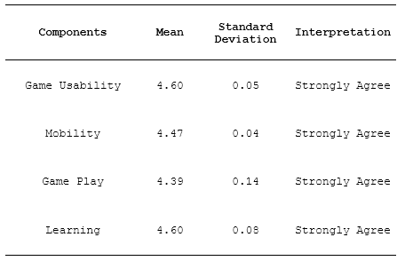

As for the results of the components, all the components garnered a “Strongly Agree” interpretation with Game Usability and Learning Content having the same mean score of 4.60 and Game Play with the lowest score of 4.39. This indicated that the game can promote learning through a positive game experience as well as an effective alternative to traditional pedagogical approaches.

Based on the cognitive theory of multimedia learning, utilizing audio and visual channels and integrating prior knowledge about a certain topic would help students retain information effectively. Since visual novels utilized both channels, along with students being familiar with the topic of Jose Rizal and had a general understanding of his love life as it was taken as a required course through high school (Filipino and History) and college (Life and Works of Rizal), it helped students with retention more so than reading through traditional text-heavy materials.

It is, however, important to take note that there is still much to improve regarding gameplay in order to make the gaming experience more meaningful and enjoyable.

CHAPTER 5 SUMMARY, CONCLUSIONS, AND RECOMMENDATIONS

Summary of the Proposed Study Design and Implementation

Visual Novels are slowly being recognized as an alternative tool that could promote learning in ways traditional learning methods cannot. Having identified several issues such as the worsening academic crisis, the Philippines struggling to keep up with the rest of the world academically, the ignorance of basic historical facts, and the teachers being forced to compete with social media as a source of reliable information; the system was built in response to these problems. These issues caused the researchers to create an interactive medium/game that could potentially assist people in learning.

Visual Novels are commonly commercialized for entertainment; however, researchers were studying their potential for learning and they had come to a mutual conclusion that incorporating them into education would be beneficial. The potential benefits of integrating it into education are high as it prescribes the Cognitive Theory of Multimedia Learning which states that in order for a person to learn effectively, the audio and visual channels should be utilized as well as having prior knowledge of the subject. Aside from that, it might be easily accessible as a huge portion of the population had phones and spent a lot of time on gadgets. It also helped people with immersion towards a subject that could only be typically learned through reading dense amounts of text as it was accompanied by visuals and sounds. A survey was conducted with total respondents of sixty-four (64) ICT students. They were asked to fill out a questionnaire that would measure their attitude toward the game. Making Visual Novels is arduous and time-consuming. It is recommended to adapt an already existing body of text like novels (Ibong Adarna, Florante at Laura, Noli me Tangere, El Filibusterismo) to lessen the time it takes to write the script and for more time spent on developing the assets, UI, music, etc.

Summary of Findings

A survey adapting the 5-point Likert scale along with the Likert scale scoring range was used in the conduct of the study. Sixty-four (64) ICT students from a University were asked to play the demo and answer the following google questionnaire form. The contents of the form pertained to the usability of the game both in the seamlessness of the gameplay and the educational content therein. The results showed that a majority of respondents found the game's usability components such as the controls to be convenient and the game adapted properly according to the screen size for both PC and mobile phone platforms.

For mobility components, the gameplay sessions were also regarded as being able to start quickly, accommodated with the surroundings and interruptions were handled reasonably.

In gameplay components, players answered that the game was adequate for learning activities.

Learning content components garnered a high score in providing learning content for the players, meaning that they were able to learn something new that they had not before after playing the visual novel.

Overall, this indicated that the game provided an overall positive learning and game experience and can be used as an effective alternative to traditional teaching methods.

Conclusions

Technical difficulties that students may face because of the online class setup give an incentive to educators to come up with ways to help students learn and retain lesson materials outside of a traditional classroom. Another issue that both students and educators face is the density of historical materials when studying subjects such as the Life and Works of Rizal– a subject mandated by law. Thus, there is a need to create learning opportunities that can engage students, especially young people, in capturing their interest in their national history.

To this end, video games and specifically visual novels were studied in this research in terms of usability and their ability to disseminate educational materials. Selected ICT Students from a University were given a copy of the game as well as a questionnaire form to fill up after they had finished playing. The general feedback was positive, with a special focus on the learning and game experience.

Recommendations

The study revealed that Visual Novels can promote learning through a positive game experience and can be used as an alternative pedagogical tool. On this basis, it is recommended to test the players by implementing a standardized scoring system and weave it within the storyline to have a quantitative basis of whether the players have learned or retained something from playing the game. In addition, adapting an already existing body of text (Ibong Adarna, Florante at Laura, Noli me Tangere, El Filibusterismo) is advised in order to cut down the time it takes to write the script and for the researchers to focus on developing the system along with the assets instead. Also, it is recommended to implement more interactive approaches within the game that would allow for more enjoyable gameplay like the option of keeping track of their progress like a journal, diary, or a box of letters that would give the players insight into the main character's internal thoughts or to unlock side stories at their own pace. Implementing more routes and raising the stakes of the consequence of their decisions is also recommended for a more meaningful game experience.

References

Abaya, M. D. (1998). *José Rizal*. *GMA Films,* Philippines. Retrieved April 13, 2022, from https://player.vimeo.com/video/447528805?h=ae7ca0b79f

Agoncillo, T. A. (1990). *History of the Filipino people*. Garotech Pub. Retrieved on April 06, 2022, from https://archive.org/details/historyoffilipin00teod

Anastasiadis, T., Lampropoulos, G., & Siakas, K. (2018). Digital Game-based Learning and Serious Games in Education. *International Journal of Advances in Scientific Research and Engineering*, *4*(12), 139–144. https://doi.org/10.31695/ijasre.2018.33016

Agusalim, I. (2015). Developing Visual Novel Game of English Conversation for DEP EEPIS. *Journal of Education and Practice*, *6*(33). https://files.eric.ed.gov/fulltext/EJ1083505.pdf

Begas, B. (2022). After MaJoHa incident, teacher Solon seeks the return of PH history in high school. Retrieved on August 15, 2022 from https://politics.com.ph/2022/04/19/after-majoha-incident-teacher-solon-seeks-return-of-ph-history-in-high-school/

Canonigo, J. (2022). *Finding Their Roots: Segunda Katigbak, Rizal’s First Love*. Istoryadista. Retrieved on April 08, 2022, from https://www.istoryadista.net/2015/02/finding-their-roots-segunda-katigbak.html

Cavallaro, D. (2010). Anime and the visual novel: Narrative structure, design and play at the crossroads of animation and Computer Games. McFarland.

CHED. (n.d.). The Life and Works of Rizal. Retrieved March 3, 2022, from https://ched.gov.ph/wp-content/uploads/2017/10/The-Life-and-Works-of-Jose-Rizal.pdf

Ercan, O. (2014). The effects of multimedia learning material on students’ academic achievement and attitudes towards science courses. Journal of Baltic Science Education, 13(5), 608–621. https://doi.org/10.33225/jbse/14.13.608

GMA News. (2011, June 19). *SONA- Ang Love Life ni Rizal* [Video]. YouTube. https://www.youtube.com/watch?v=1gcpzAX43G8

Guerrero, L. M., & Quirino, C. (2021). *The First Filipino: A biography of Jose Rizal*. National Historical Commission of the Philippines. Retrieved on March 05, 2022, from http://www.xeniaeditrice.it/firstfilipinoocrpdf.pdf

Gutierrez, J., &amp; Bilefsky, D. (2021). With schools closed, COVID-19 deepens a Philippine Education Crisis. The New York Times. Retrieved January 5, 2022, from https://www.nytimes.com/2021/09/13/world/asia/philippines-students-remote-covid.html

Hakim, H. B., Sari, Z., Sarosa, M. & Suhari. (2017). Multiplatform Visual Novel for Culture Education in a Part of Using ICT For Developing Lifelong Learning. Retrieved June 27, 2022 from https://jurnal.unmer.ac.id/index.php/sdgs/article/view/1598/1190

Katigbak, R. (2010). *Lipa’s Old Gentry*. Hirencia Lipena. Retrieved on May 27, 2022, from https://herencialipena.com/culture/lipasoldgentry/

Katigabak, R. (2022). *Segunda Solis Katigbak: The Charming Lipeña Who Captivated Rizal’s Young Heart*. Hirencia Lipena. Retrieved on June 16, 2022 from https://herencialipena.com/2022/01/16/segunda-solis-katigbak/

Limos, M. A. (2018). *Leonor Rivera: The Tragic Story of Jose Rizal’s Most Significant Love and Heartbreak*. Esquire PH. Retrieved on April 15, 2022, from https://www.esquiremag.ph/the-good-life/pursuits/leonor-rivera-the-tragic-story-of-jose-rizal-s-most-significant-love-and-heartbreak-a1957-20180612-lfrm2

Limos, M. A. (2018). Quirks and Sins: The Humanity of Our Hero, Jose Rizal. *Esquire PH*. Retrieved on April 24, 2022, from https://www.esquiremag.ph/the-good-life/pursuits/quirks-and-sins-the-humanity-of-our-hero-jose-rizal-a1957-20180619-lfrm

Limos, M. A. (2018). How Wealthy Was the Rizal Family? *Esquire PH*. Retrieved on April 29, 2022, from https://www.esquiremag.ph/the-good-life/pursuits/rizal-family-net-worth-a1957-20181020-lfrm

Limos, M. A. (2019). *Jose Rizal as a Lover: How He Two-Timed Two Women Until He Got Caught*. Esquire PH. https://www.esquiremag.ph/the-good-life/pursuits/jose-rizal-segunda-katigbak-relationship-a1957-20190214-lfrm

Limos, M. A. (2020). Jose Rizal’s Girlfriends and His Naughty Amusements. *Esquire PH*. Retrieved on May 07, 2022, from https://www.esquiremag.ph/long-reads/features/jose-rizal-girlfriends-and-amusements-a00293-20200305

Lochman, M. (2020). Program Planning through a Visual Novel-style Game. In *ScholarSpace*. https://scholarspace.manoa.hawaii.edu/bitstream/10125/67815/MLochman_LTEC690_Final2020.pdf

Martel, T. (2011). Stories of romance in the house of Rizal's first love. *PhilStar*. Retrieved on April 08, 2022, from https://www.philstar.com/lifestyle/sunday-life/2011/05/01/680929/stories-romance-house-rizals-first-love

Mateo, J. (2020). As Classes Open, ‘Learning Crisis’ Highlighted With Millions Of Students Left Behind. Retrieved February 6, 2022, from https://www.onenews.ph/articles/as-classes-open-learning-crisis-highlighted-with-millions-of-students-left-behind

Mayer, R. E. (1997). Multimedia learning: Are we asking the right questions? Educational Psychologist, 32(1), 1–19. https://doi.org/10.1207/s15326985ep3201_1

Mayer, R. E. (2002). Multimedia learning. Psychology of Learning and Motivation, 85–139. https://doi.org/10.1016/s0079-7421(02)80005-6

Mayer, R. E. (n.d.). Cognitive theory of multimedia learning. The Cambridge Handbook of Multimedia Learning, 43–71. https://doi.org/10.1017/cbo9781139547369.005

Ocampo, A. R. (2021). *Queridas de Rizal: Looking Back*. Anvil Publishing, Philippines.

Ocampo, A. R. (1999). *Rizal without the overcoat*. Anvil Publishing, Philippines. Retrieved on March 13, 2022, from https://pdfcoffee.com/rizal-without-the-overcoatdocx-pdf-free.html

Online education: Today's alternative learning for students. ChildHope Philippines. (2021, October 22). Retrieved January 5, 2022, fromhttps://childhope.org.ph/alternative-learning-online-education/

Owen, N. G. (2007). *Maria Clara and the Market: Women and Change in the 19th Century Philippines*. Asian Studies. Retrieved on March 19, 2022, from https://asj.upd.edu.ph/mediabox/archive/ASJ-36-1-2000/owen.pdf

Prasetyo, R. A., & Kuswardani, R. (2021). Developing students’ reading ability using visual novel for high school students. *Journal of Research on English and Language Learning (J-REaLL)*, *2*(2), 132. https://doi.org/10.33474/j-reall.v2i2.11336

Reyes, R. A. G. (2008). *Love, Passion and Patriotism: Sexuality and the Philippine Propaganda Movement, 1882 - 1892*. NUS Press. Retrieved on April 02, 2022, from https://eprints.soas.ac.uk/29221/1/10731316.pdf

Rizal, J. P. (1918). *Rizal's Own Story of His Life*. Manila: National Book Co. Retrieved on March 25, 2022, from https://www.gutenberg.org/files/48438/48438-h/48438-h.htm

Roth, E. (2019). Are Visual Novels Video Games? Well, It Depends…Retrieved on January 10, 2022 from https://whatnerd.com/visual-novels-video-games/

Salazar, F. L., Nakajima, T., &amp; Alexandrova, T. (2013). Visual novels: An methodology guideline for pervasive educational games that favors discernment. Grid and Pervasive Computing, 234–243. https://doi.org/10.1007/978-3-642-38027-3_25

Scepanovic, S., Vujicic, T., Matijevic, T. & Radunovic, P. (2015). Game-Based Mobile Learning - Application Development and Evaluation. Retrieved on August 20, 2022 on http://elearning.metropolitan.ac.rs/files/pdf/2015/22-Snezana-Scepanovoc-Tijana-Vujicic-Tripo-Matijevic-Petar-Radunovic-Game-based-mobile-learning-application-development-and-evaluation.pdf

Simkova, M. (2014). Using of Computer Games in Supporting Education. *Procedia - Social and Behavioral Sciences*, *141*, 1224–1227. https://doi.org/10.1016/j.sbspro.2014.05.210

Uy, S. L. (2018). A Few Things About Rizal That History Books Don't Mention. *Esquire PH*. Retrieved on May 18, 2022, from https://www.esquiremag.ph/culture/lifestyle/10-things-you-didnt-know-about-jose-rizal-sa00204-20180619-src-spot-lfrm

Valencia, S. (2014, June 27). *When High School Students Struggle with Textbook Reading*. Edutopia. https://www.edutopia.org/blog/students-struggle-with-textbook-reading-sheila-valencia

Villanueva, R. (2021). Child rights group alarmed over low enrollment. Retrieved on January 5, 2022 from https://www.philstar.com/nation/2021/09/10/2126066/child-rights-group-alarmed-over-low-enrollment#:~:text=MANILA%2C%20Philippines%20%E2%80%94%20A%20group%20promoting,for%20school%20year%202021%E2%80%932022

Virvou, M., Katsionis, G., & Manos, K. (2005). Combining Software Games with Education: Evaluation of its Educational Effectiveness. *Journal of Educational Technology & Society*, *8*(2), 54–65. https://www.jstor.org/stable/jeductechsoci.8.2.54

Visual novel. TV Tropes. (n.d.). Retrieved January 7, 2022, from https://tvtropes.org/pmwiki/pmwiki.php/Main/VisualNovel

Appendices

Appendix A

Letter to the Adviser

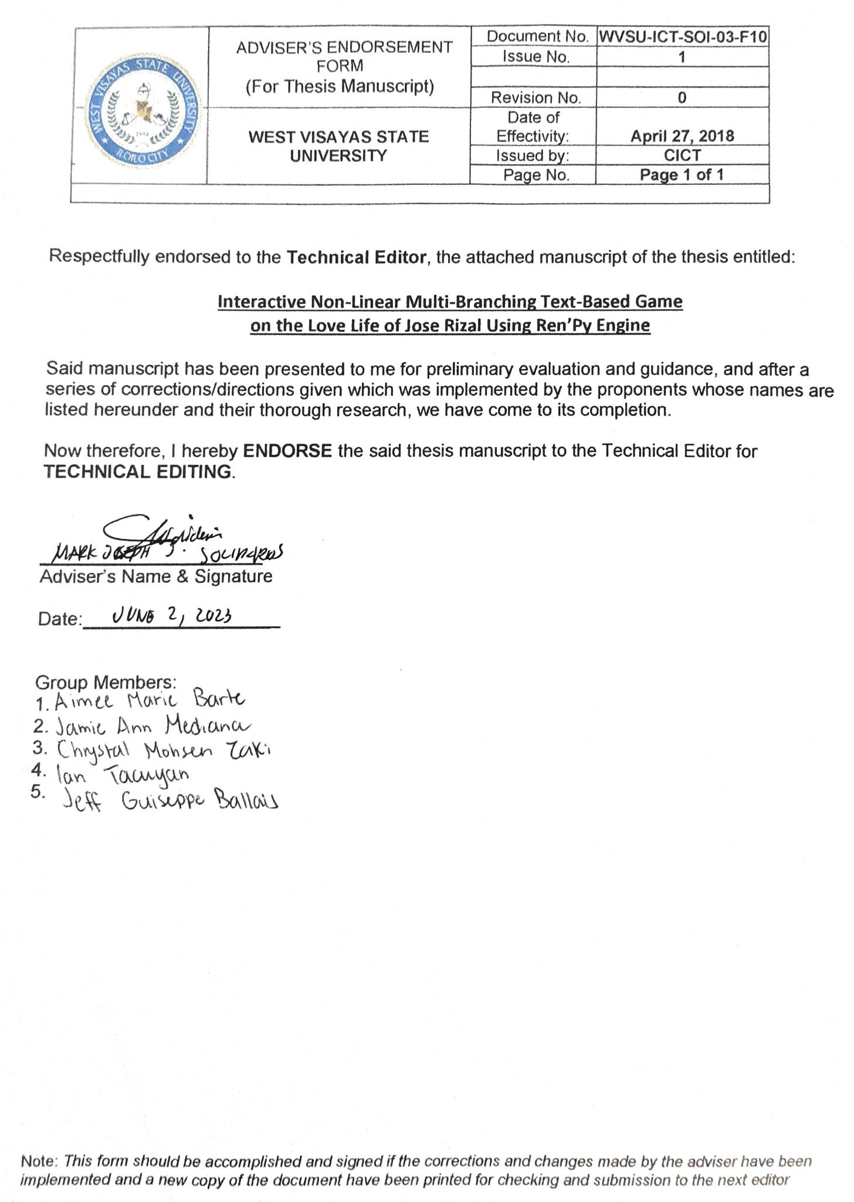

Appendix B

Letter to the Technical Editor

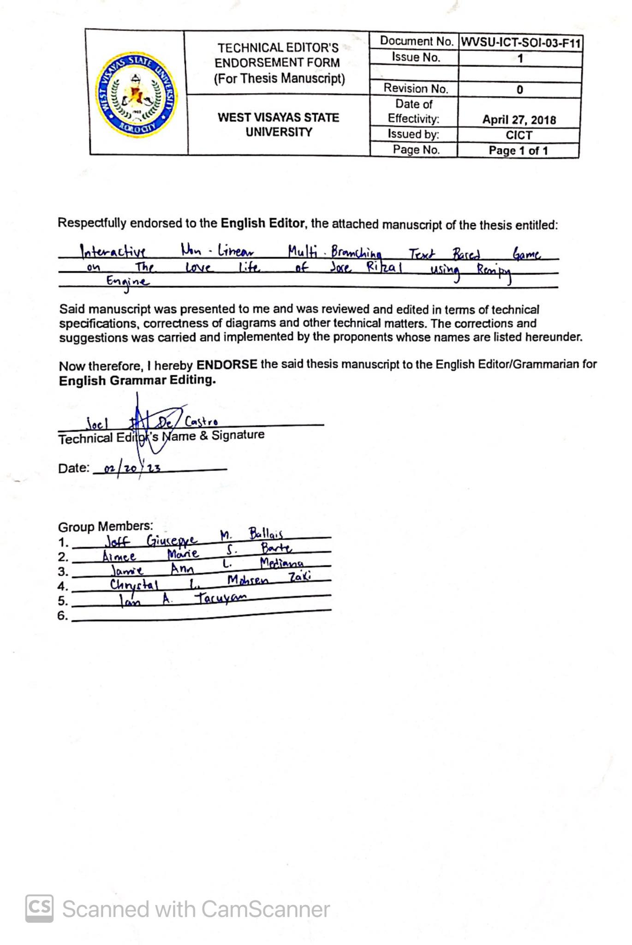

Appendix C

Letter to the English Editor

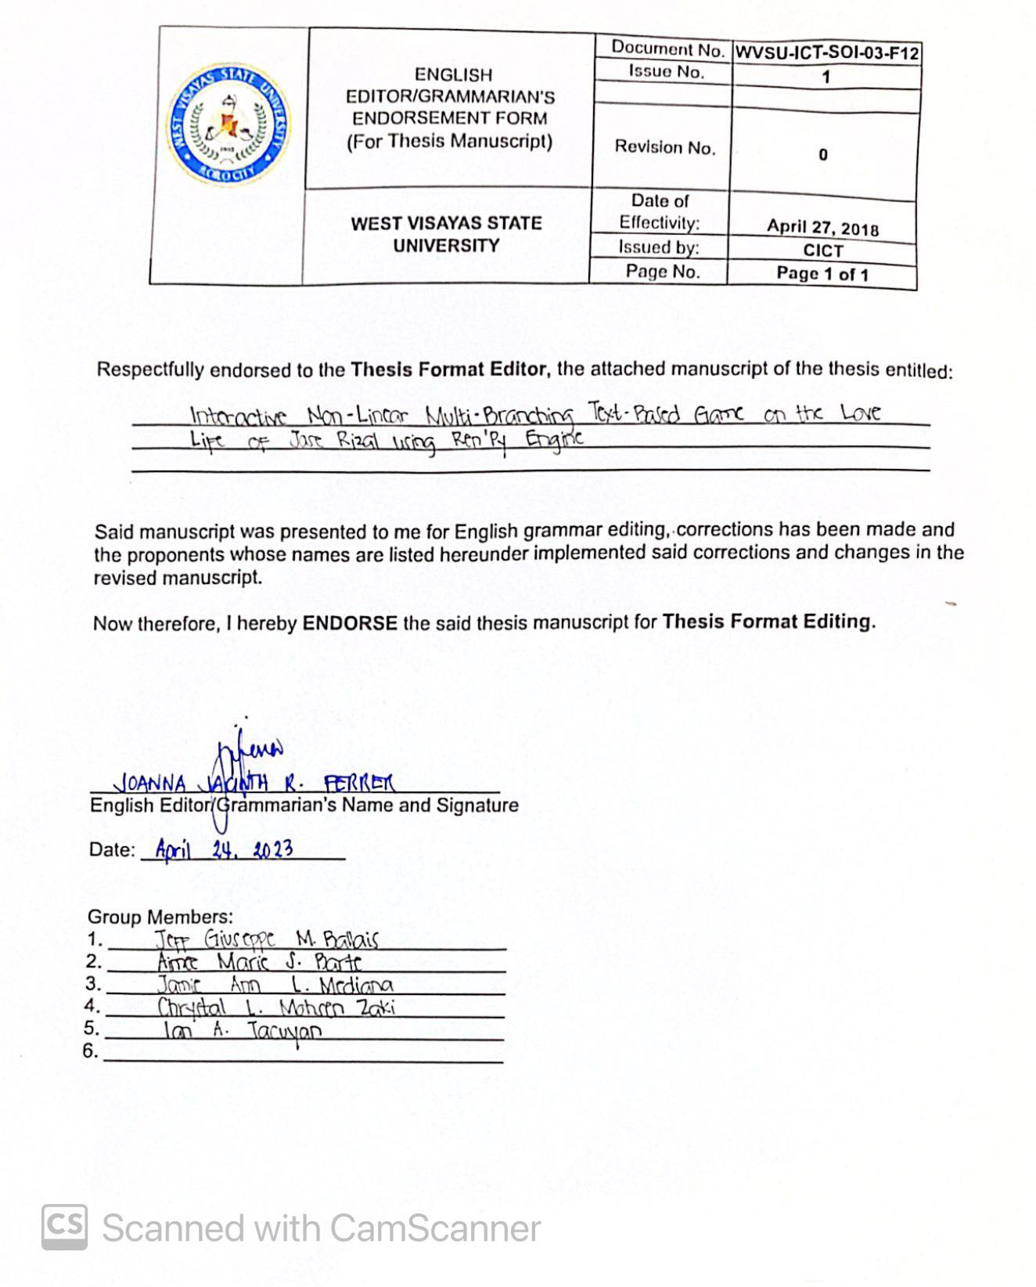

Appendix D

Letter to the Format Editor

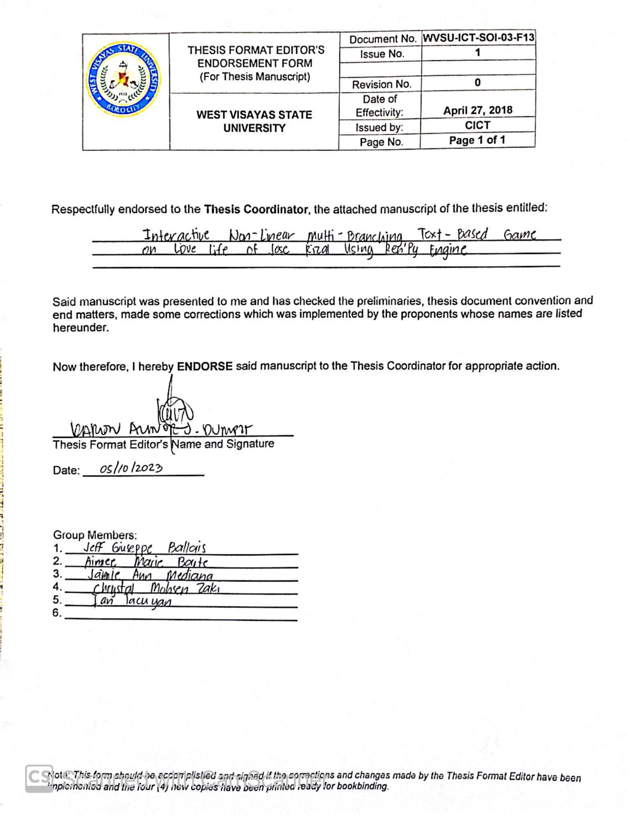

Appendix E

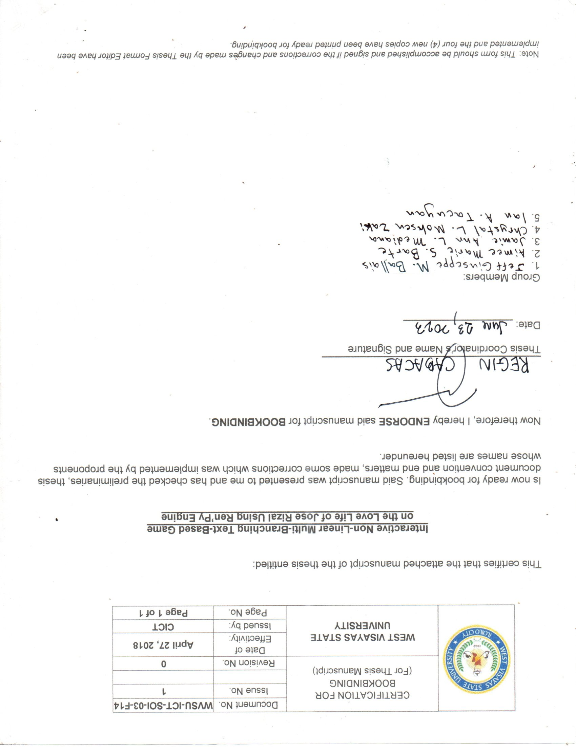Certification for Bookbinding

Appendix F

Letter to Validator

September 10, 2022

**DR. LEAH CABALFIN**  
CAS FACULTY

College of Arts and Sciences  
West Visayas State University

Luna St. La Paz, Iloilo

Dear Dr. Cabalfin,

The undersigned are BS in Entertainment Multimedia Computing taking up Research 1 under the College of ICT in this University and are currently conducting a thesis project entitled *“****Love Doctor Rizal: A Visual Novel on the Love Life of Jose Rizal****”.*

In connection with this, we are inviting you to be our Validator for the said thesis project. Attached are the brief overview of the progress made.

We are looking forward to your kind consideration and positive response. Thank you very much.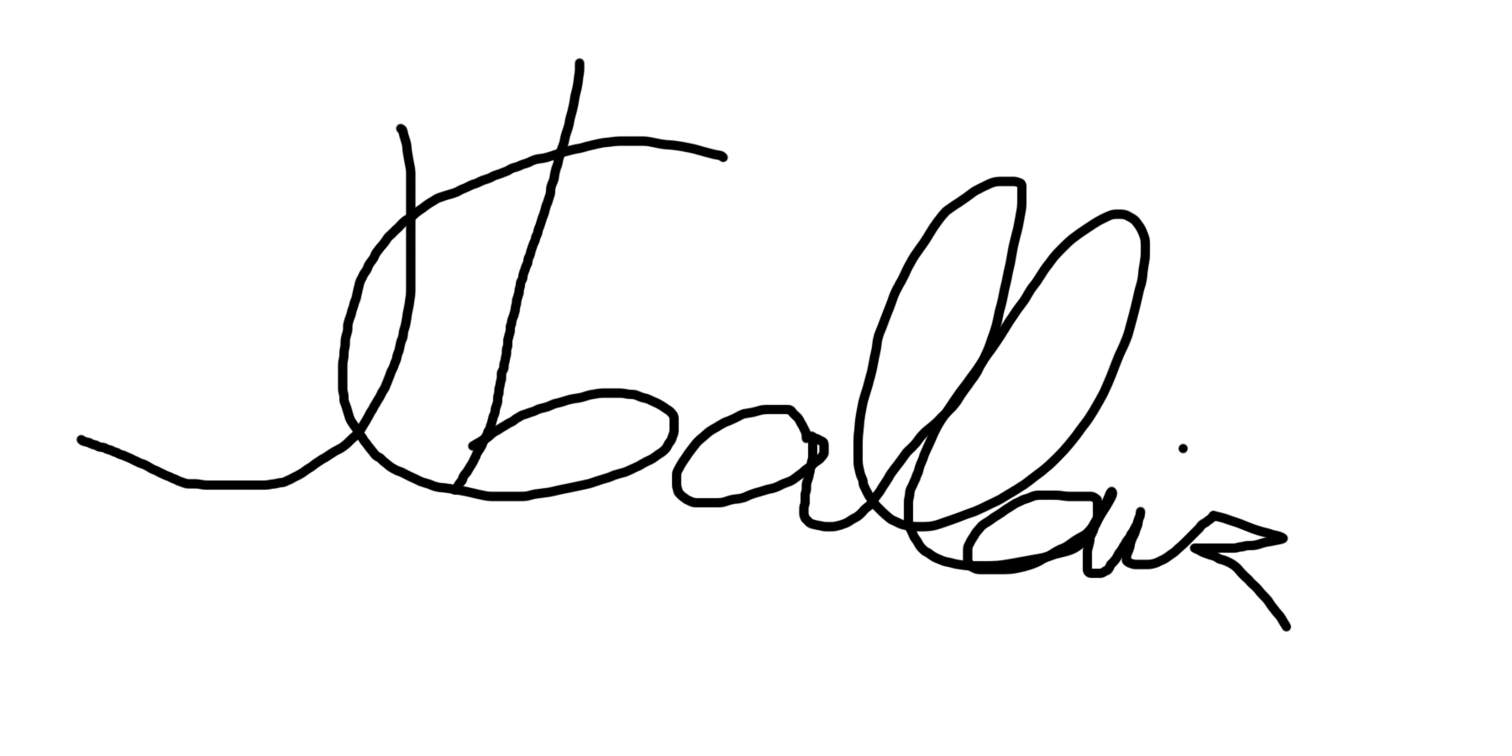

**AIMEE BARTE**  **JAMIE MEDIANA** **JEFF BALLAIS** Researcher Researcher Researcher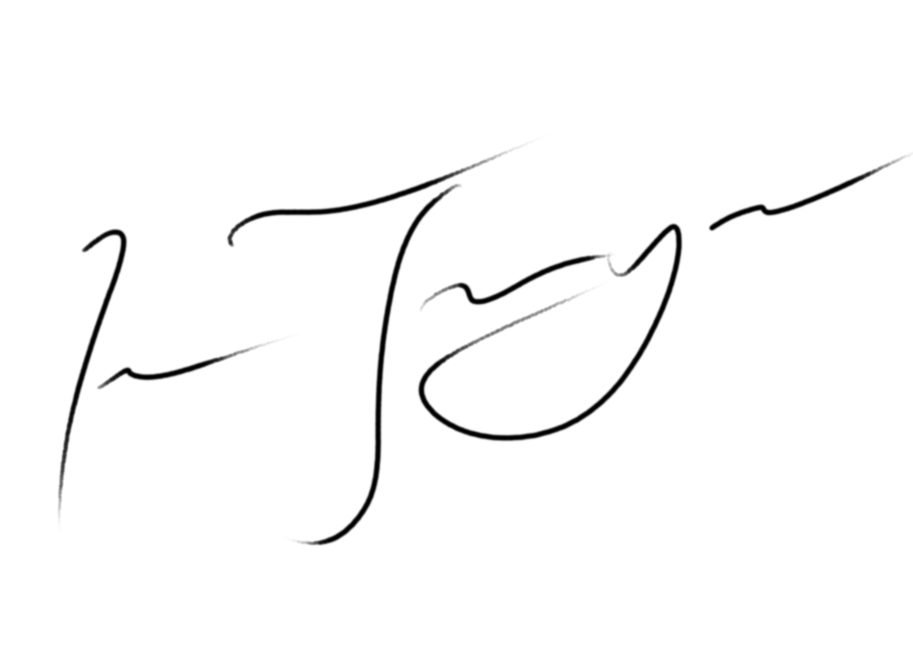

**CHRYSTAL MOHSEN ZAK**I **IAN TACUYAN** Researcher Researcher

Noted:

**MARK SOLIDARIOS**  Thesis Adviser

Approved:

**DR. LEAH CABALFIN**  CAS Faculty

September 8, 2022

**PROF. JOYCE CHRISTINE COLON**

CAS FACULTY

College of Arts and Sciences

West Visayas State University

Luna St. La Paz, Iloilo

Dear Prof. Colon,

The undersigned are BS in Entertainment Multimedia Computing taking up Research 1 under the College of ICT in this University and are currently conducting a thesis project entitled *“****Love Doctor Rizal: A Visual Novel on the Love Life of Jose Rizal****”.*

In connection with this, we are inviting you to be our Validator for the said thesis project. Attached are the brief overview of the progress made.

We are looking forward to your kind consideration and positive response. Thank you very much.

**AIMEE BARTE**  **JAMIE MEDIANA** **JEFF BALLAIS** Researcher Researcher Researcher

**CHRYSTAL MOHSEN ZAK**I **IAN TACUYAN** Researcher Researcher

Noted:

**MARK SOLIDARIOS**  Thesis Adviser

Approved: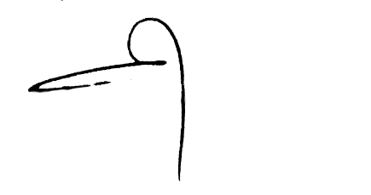

**PROF. JOYCE CHRISTINE COLON** CAS Faculty

Appendix G

Survey Questionnaire

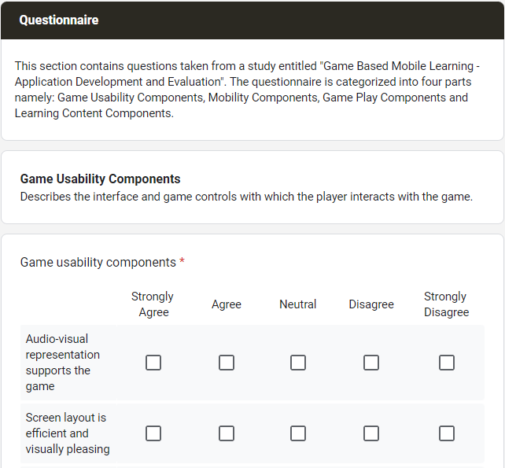

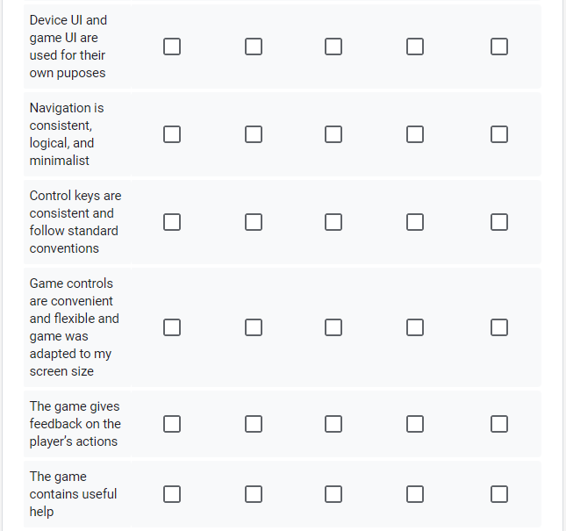

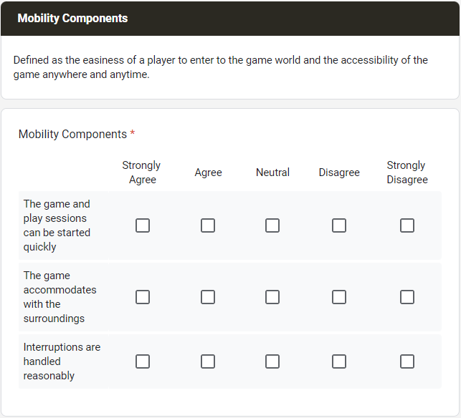

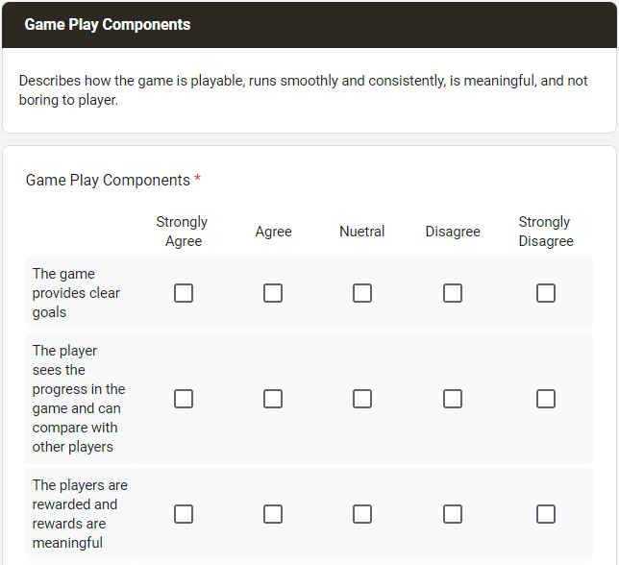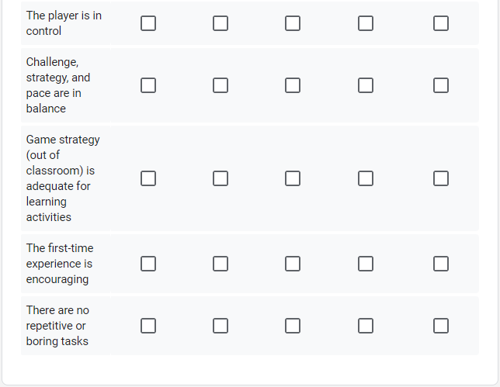

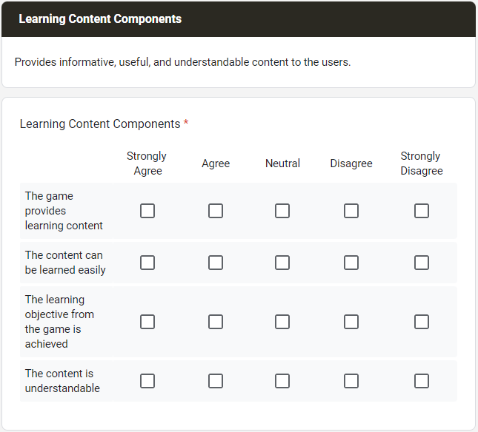

Appendix H

Raw Data and Statistical Computations

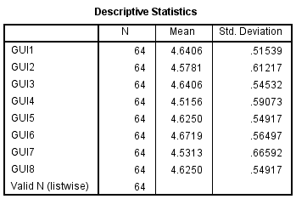

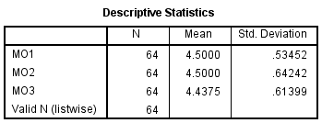

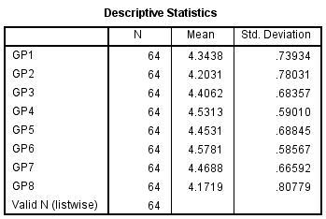

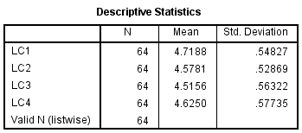

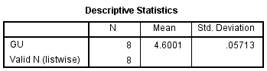

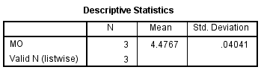

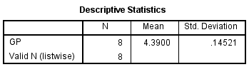

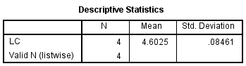

Appendix I

Sample Script

**Love Doctor Rizal Part 1**

**INT. BAHAY NA BATO - AZOTEA - DAY**

Mariano, Segunda and Jose’s lola are at the side. Drinking coffee. Talking. Jose is seated facing Manuel, a chessboard in front.

Jose was initially determined to beat his opponent. What with the previous disaster that was a week ago, he is set on making up for his foolishness.

But with the way things are, it looks like Jose has to deal with the short end of the stick once again. Manuel is relaxed in his chair. Jose impatiently taps his feet.

**MANUEL**

We still have plenty of time.

Jose glances at him and immediately shifts his focus back at the chessboard. *“He’s good, he’s plenty good”*. Jose makes his move. Manuel tries his best to control the slight tug forming on the corner of his mouth. Jose knows he did terribly. Manuel moves his piece. Mariano stands beside the chessboard.

**MARIANO**

You look like you’re in a tight

spot there, mate.

**JOSE**

Oh hush Mariano, I’m concentrating.

Mariano shrugs.

**LOLA**

Looks like we’re running out of

snacks. Segunda, dear. Can you accompany

me to the kitchen?

Segunda nods and sets her cup on the table. She looks at Jose’s direction and finds him looking at her too. They both turn away quickly. Jose is met with Manuel’s knowing smile. He suddenly becomes tense.

**MARIANO**

Oh, I’ll go too!

**SEGUNDA**

You just want to see Rosario.

**MARIANO**

What? No, of course not.

Their voices fade. Jose focuses on the chessboard. He pretends as if Manuel didn’t just catch him exchanging looks with his fiancee.

**MANUEL**

It looks like you’ve gotten closer

with Segunda.

Jose tries his best to not look bothered, or nervous for that matter.

**JOSE**

We’re friends.

**MANUEL**

I can see that.

They move their respective pieces. The game is getting tougher.

**MANUEL**

Segunda is a nice girl and

I’m happy to see her gain

new friends.

**JOSE**

I’m glad to hear that.

An uncomfortable silence ensues. Manuel shatters it just as quickly as it materialized.

**MANUEL**

When I was your age, I did plenty

of things that could potentially

threaten the family honor. In secret,

of course. The Katigbaks have no idea.

Manuel chuckles. Jose does not know how to react.

**MANUEL**

I’ve long since learned my lesson

and decided that if you have no better

use of your time, the best course

of action is no action at all.

Jose has no idea where this conversation is heading which is making him more anxious by the minute. Manuel moves his chess piece.

**MANUEL**

You know of my relationship with

her, right?

**JOSE**

Yes.

**MANUEL**

Then you know that it is my

responsibility to look out for her

for any potential…concerns.

**JOSE**

Yes.

Jose hovers his hand over a chess piece. Manuel observes his movements.

**MANUEL**

Think about how your single

move could affect the outcome.

Jose pauses and looks at him. Manuel doesn’t seem angry or even frightening for that matter. He gestures for Jose to go ahead.

Jose moves his chess piece. Manuel smiles, a wide smile. Almost sinister. He moves his piece. Jose inspects the chessboard even further wondering where he could possibly go wrong. *‘There it is’*, Jose is now able to see the whole picture. He can’t believe he got himself caught in Manuel’s web when he seriously thought he could see the game through to the end only dealing with minor setbacks. *‘Why did it take me so long to see it?’*, and it is as if Jose was hit with the force of a sledgehammer.

Manuel has been playing the waiting game all along. With his level of skill he could have destroyed Jose in a matter of a few moves but he chose to wait and strike him when he is the most vulnerable. Manuel planned to trap him from the start. He is now surrounded and any movement from his side would ultimately cost him his queen. Jose could feel a rising panic from the depths of his stomach. How cruel.

**SEGUNDA**

We’re ba–

**JOSE**

I concede!

Everyone is surprised at his outburst. Even Jose himself is surprised.

**JOSE**

(calmly)

I– I concede…

Manuel offered an understanding smile. He raises his hand for a handshake. Jose accepts.

**MANUEL**

It was a good game, Jose.

It was the most entertaining

game I played in a while.

**JOSE**

Yeah, haha…I’m glad to be

of service…

Segunda offers both of them a mug of warm coffee. The kind gesture isn’t enough to make Jose feel at ease.

**MANUEL**

I talked to Jose. He would

make a good friend.

Segunda seems alarmed.

**SEGUNDA**

What did you tell him?

Manuel, tell me at once.

Manuel walked inside the house, teasingly ignoring Segunda. Segunda’s pleas are in earshot. Mariano pats him on the shoulder in an attempt to comfort him.

**MARIANO**

He’s good, huh?

**JOSE**

Better than I expected. He

can also be quite…scary.

**MARIANO**

Ahhh, yes. Manuel likes his games.

Especially his mind games. That’s why

father likes him. He knows how to deal

with his cards. Says he’s the most

suitable candidate to continue the

family legacy. Kinda stings, to be

honest.

Jose pats him on the back in return. It was quite laughable, his attempts to keep the queen when he was doomed from the very start. Manuel isn’t someone people should cross and he made that clear. All Jose knows is that he refuses to be a pawn in Manuel’s game of chess.

Appendix J

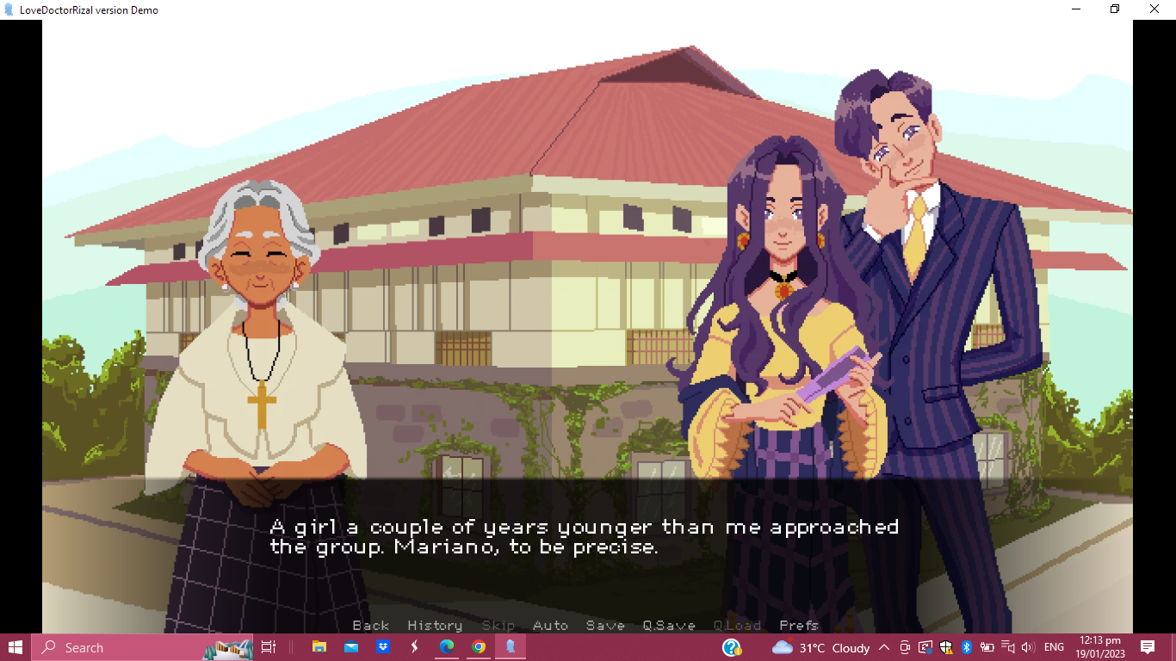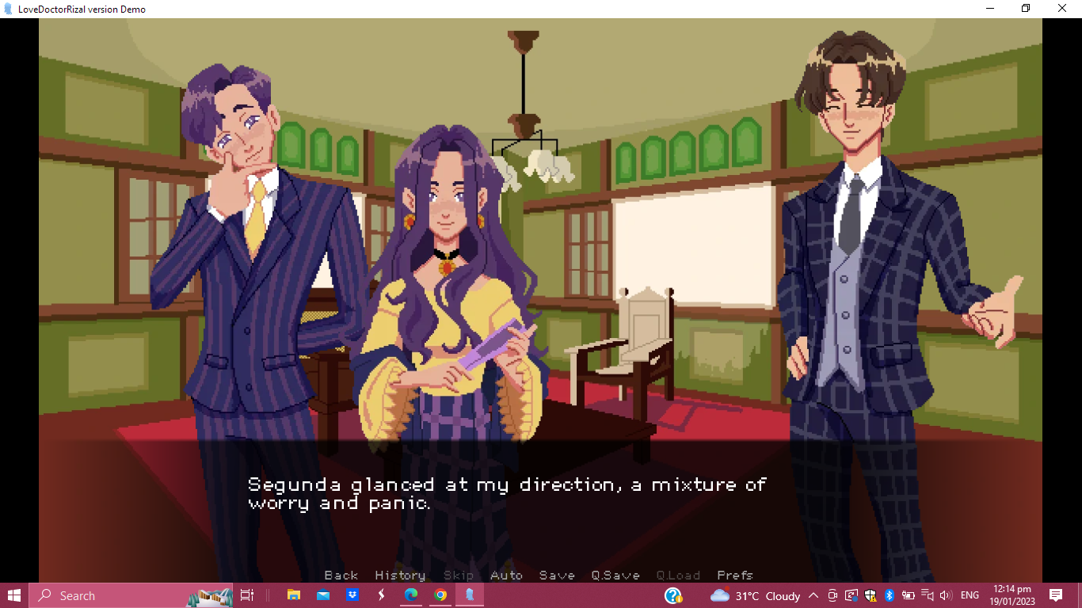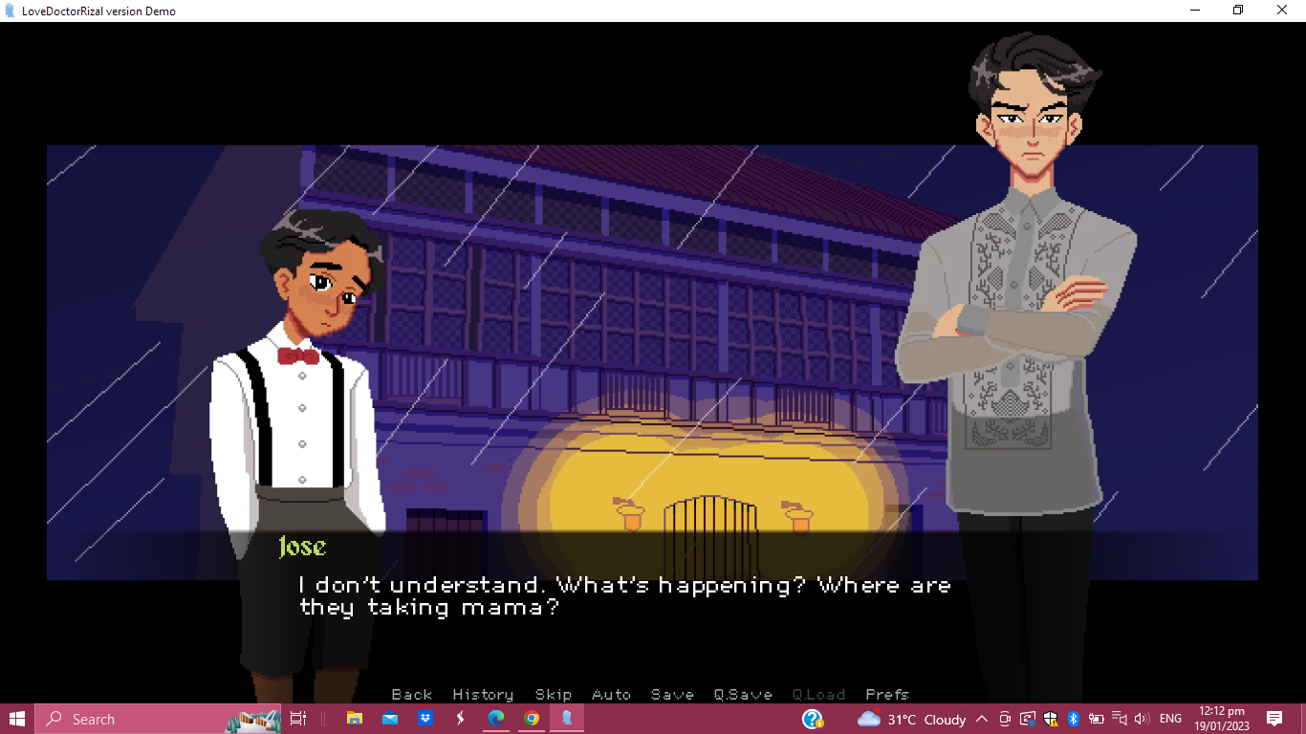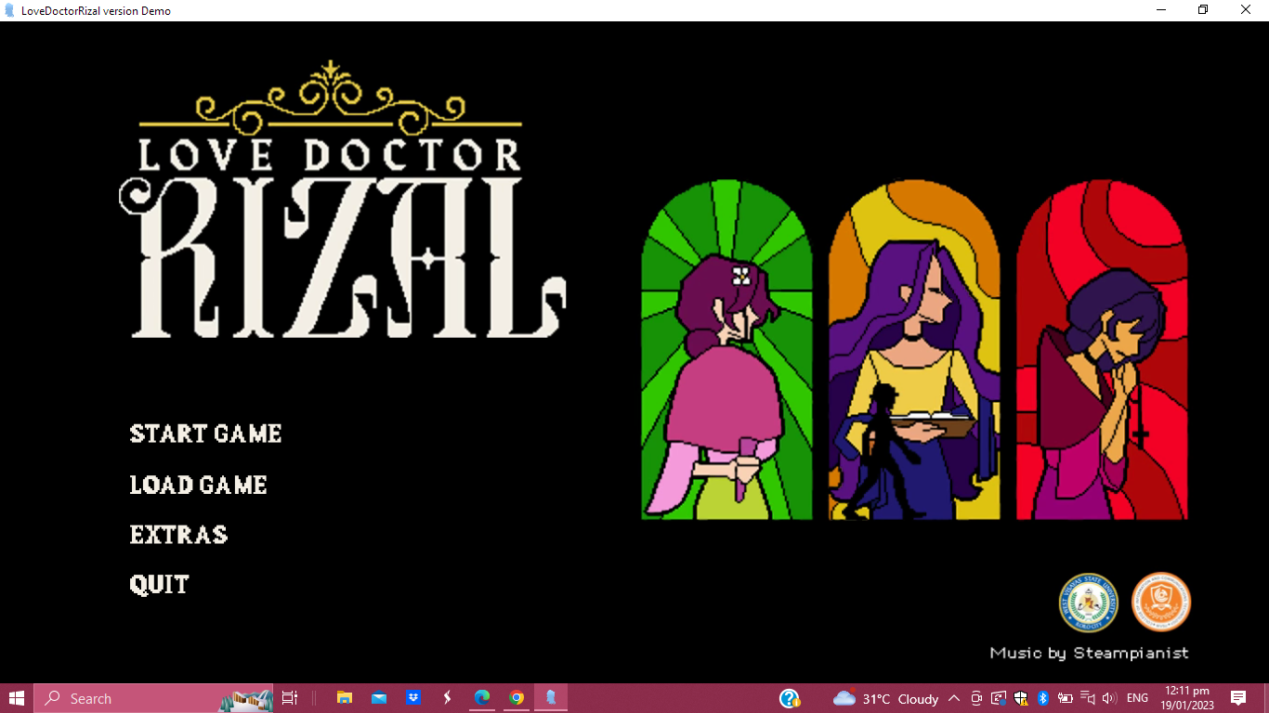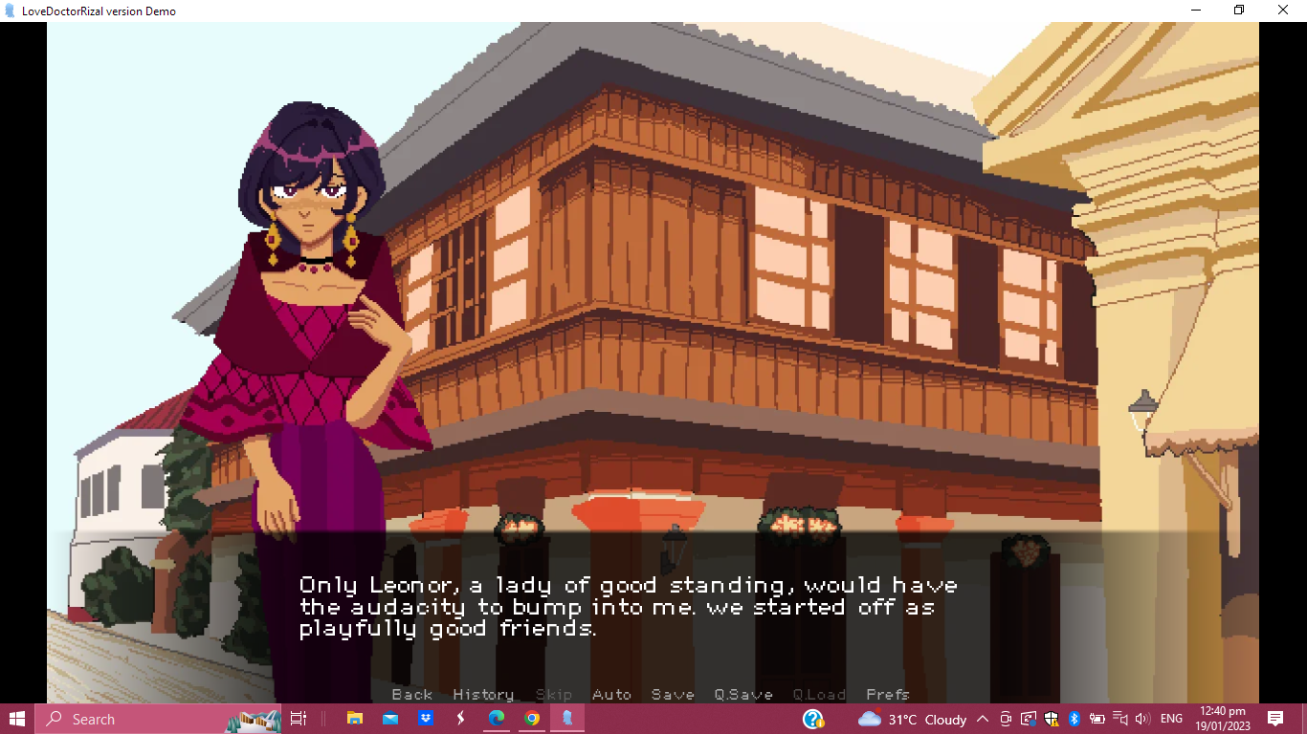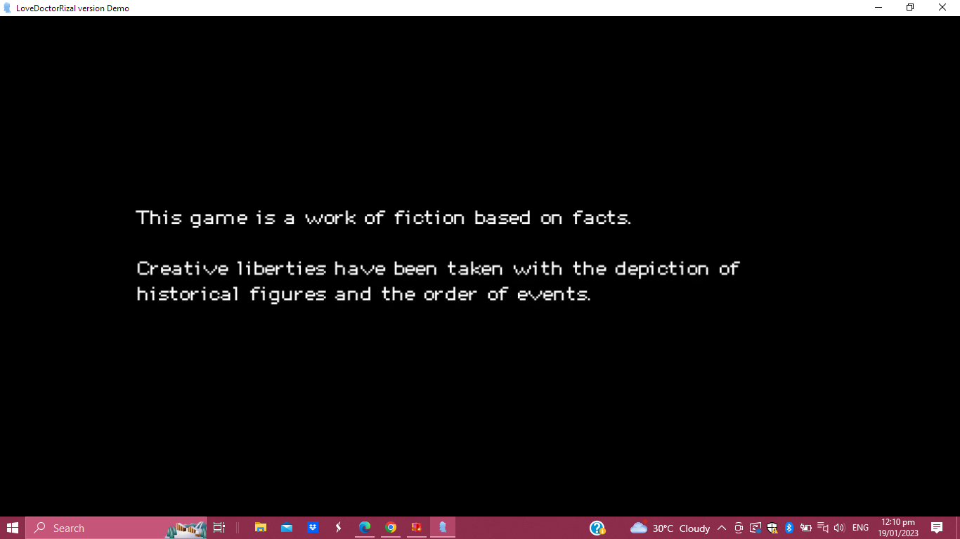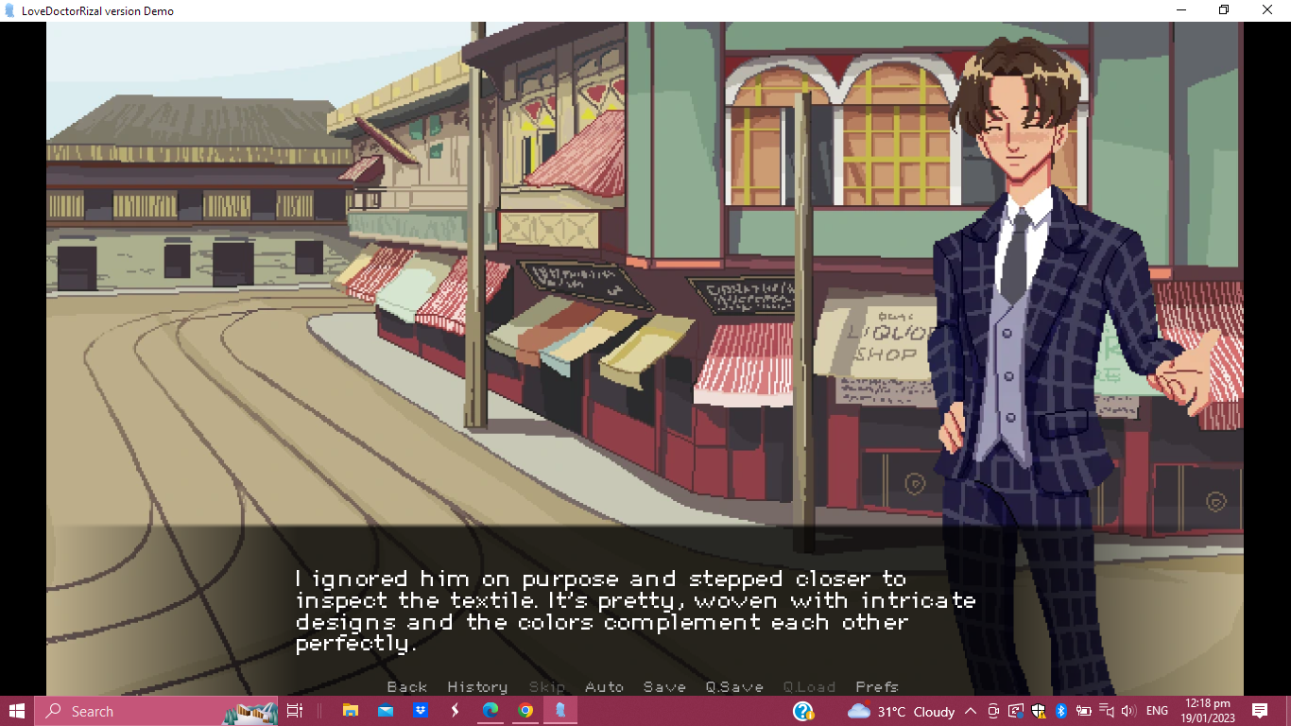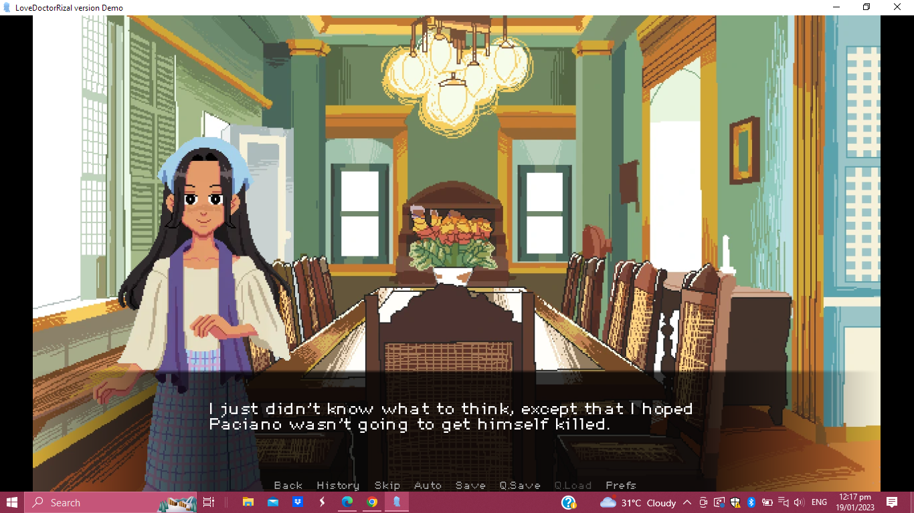Sample Screenshots

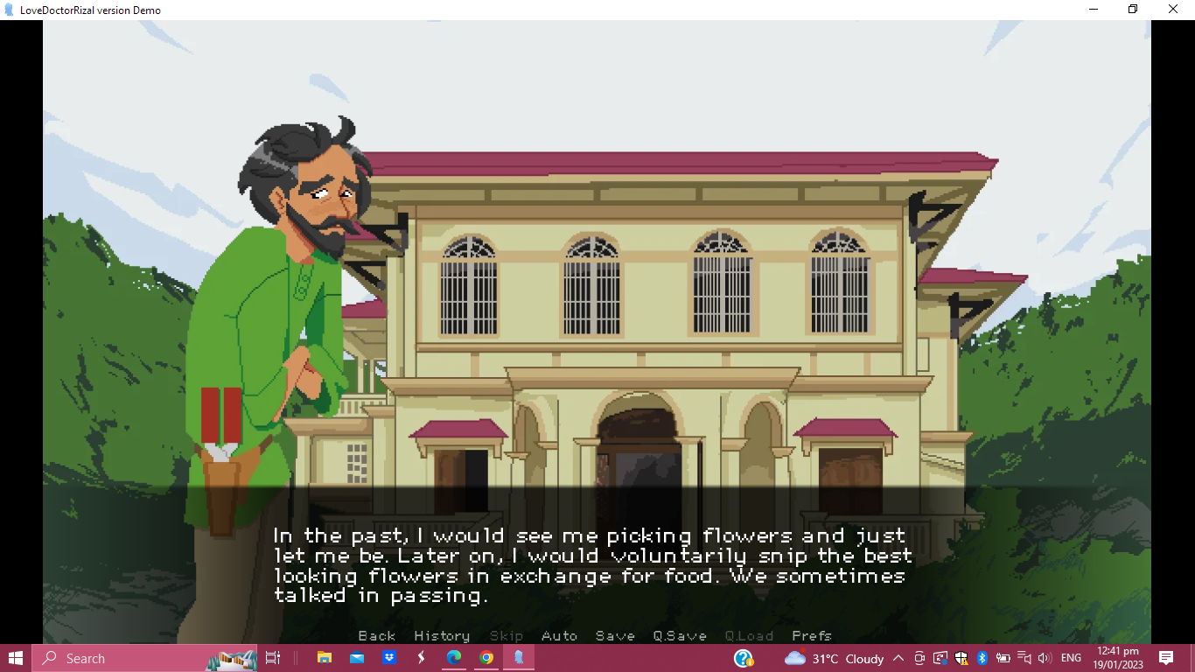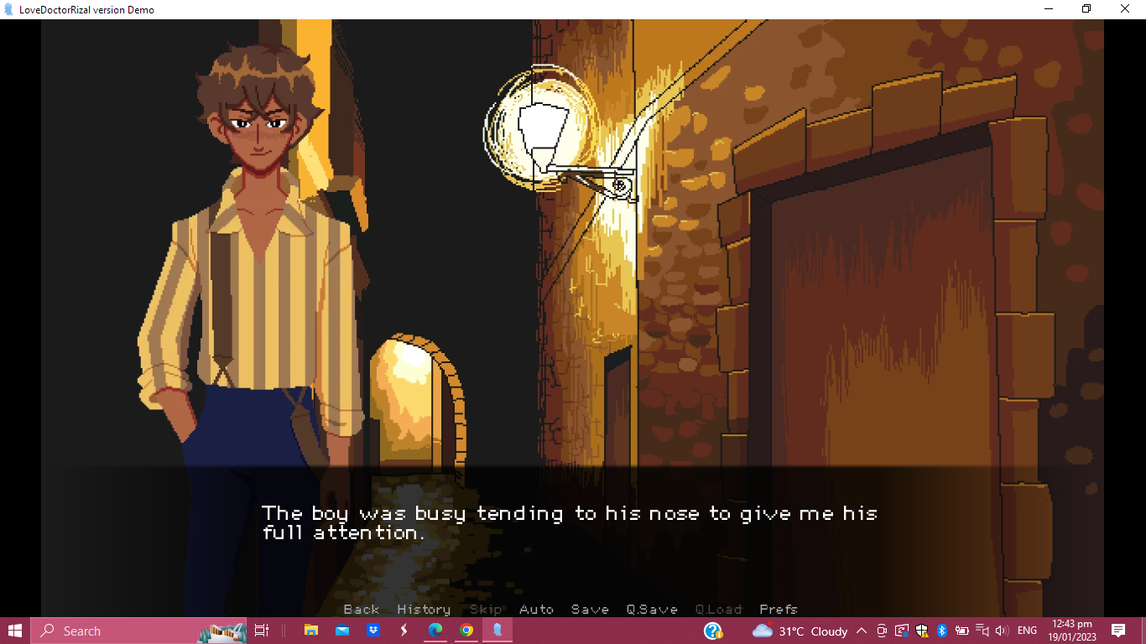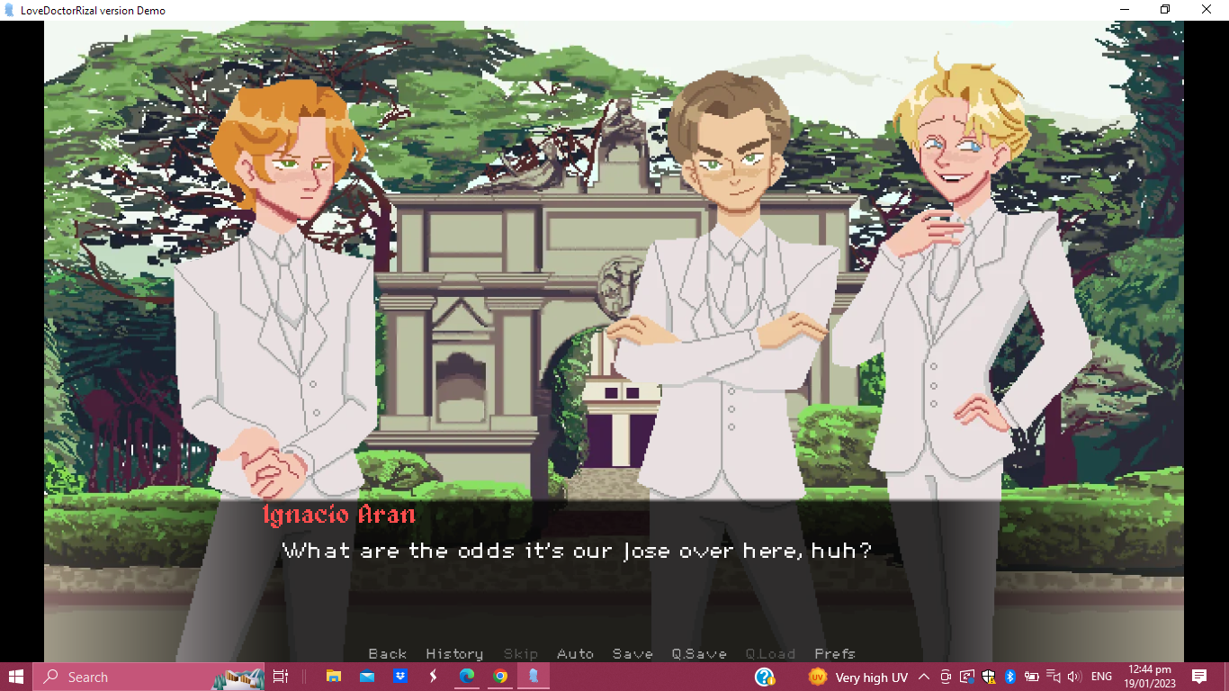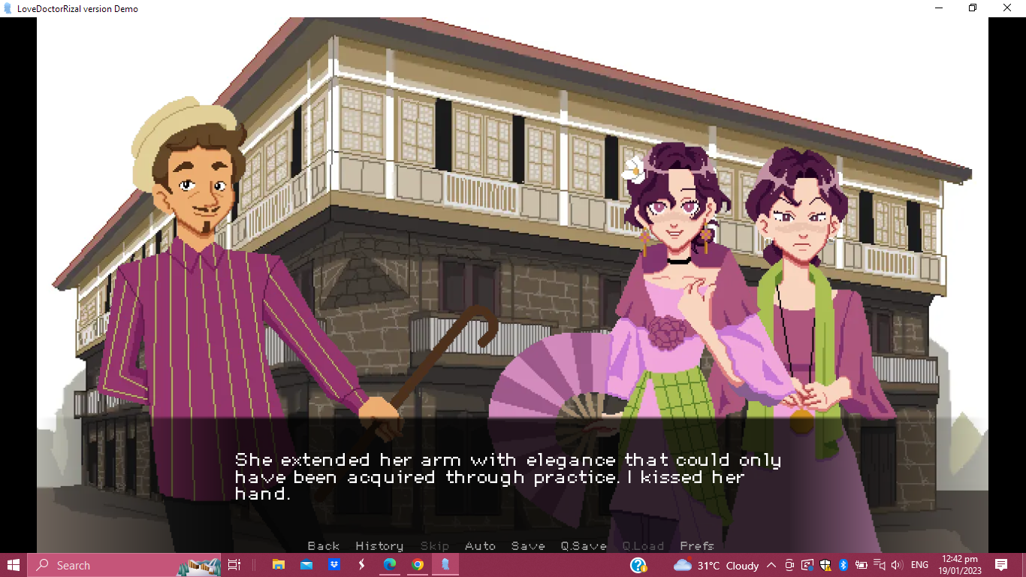

Appendix K

CGI Cutscenes

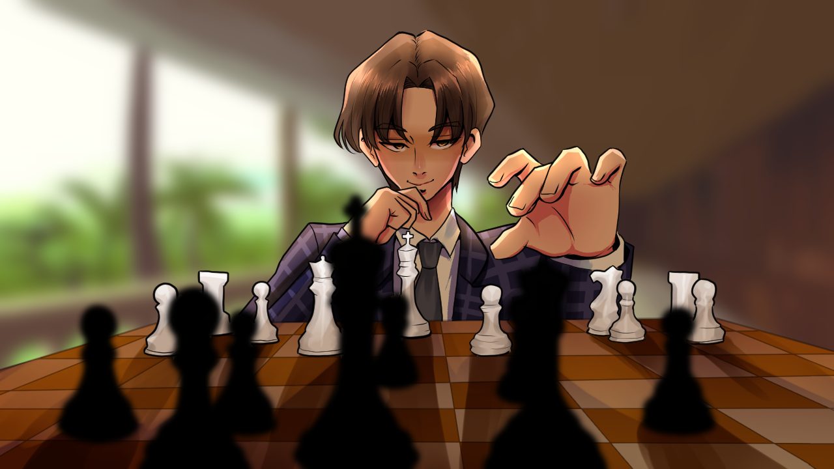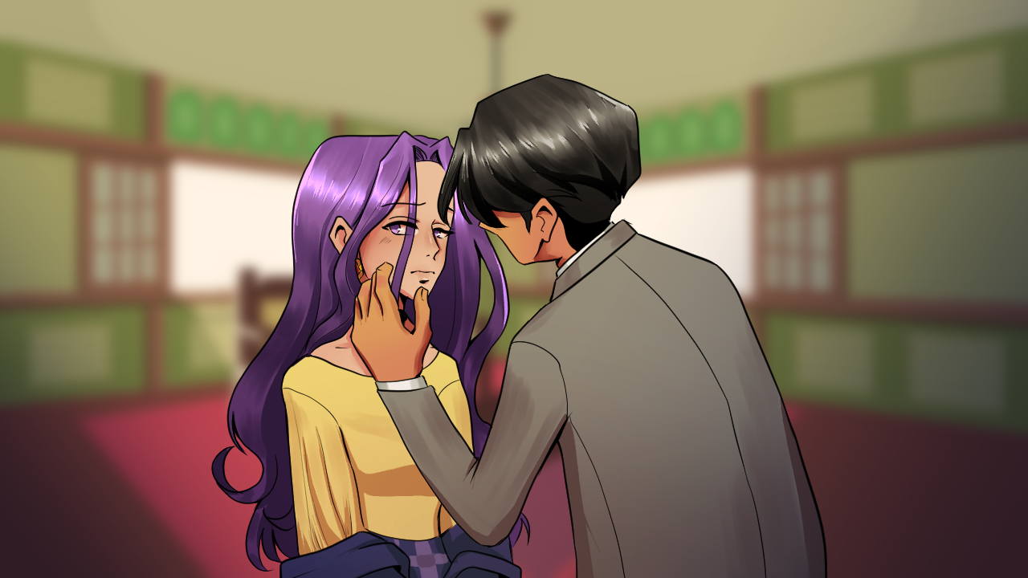

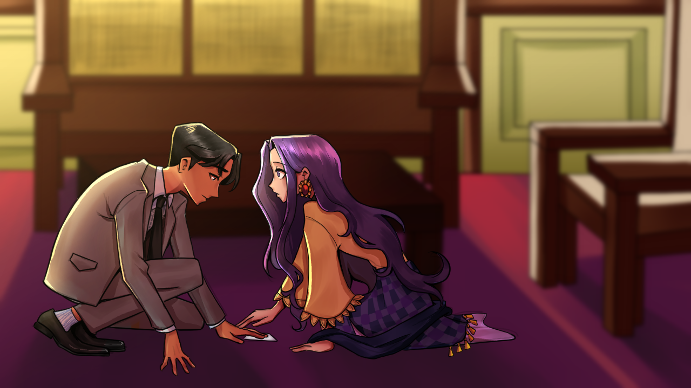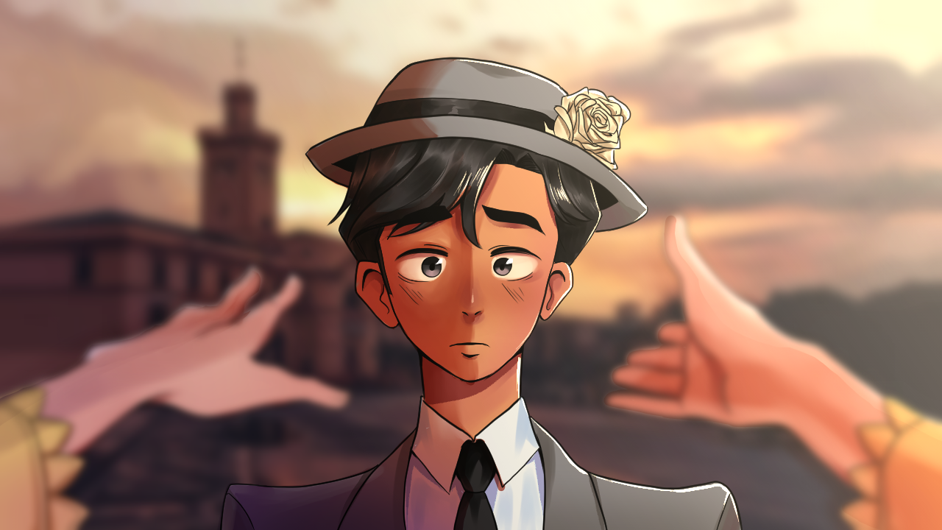

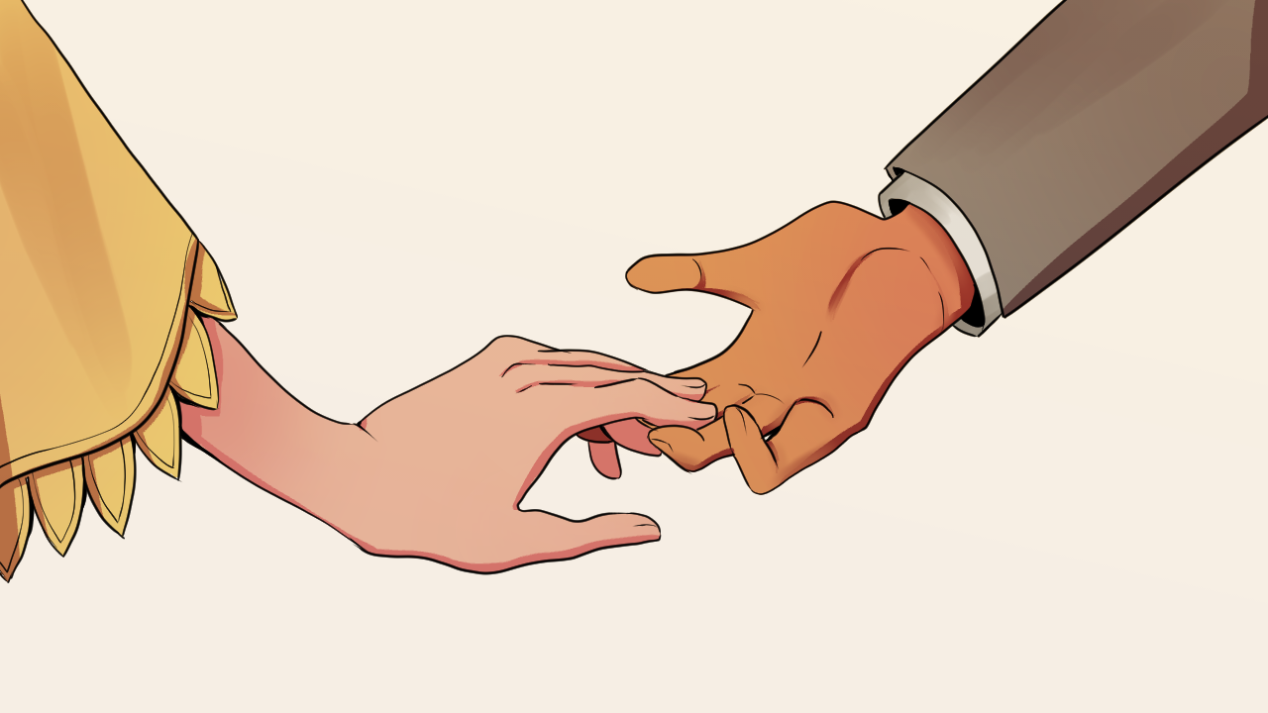

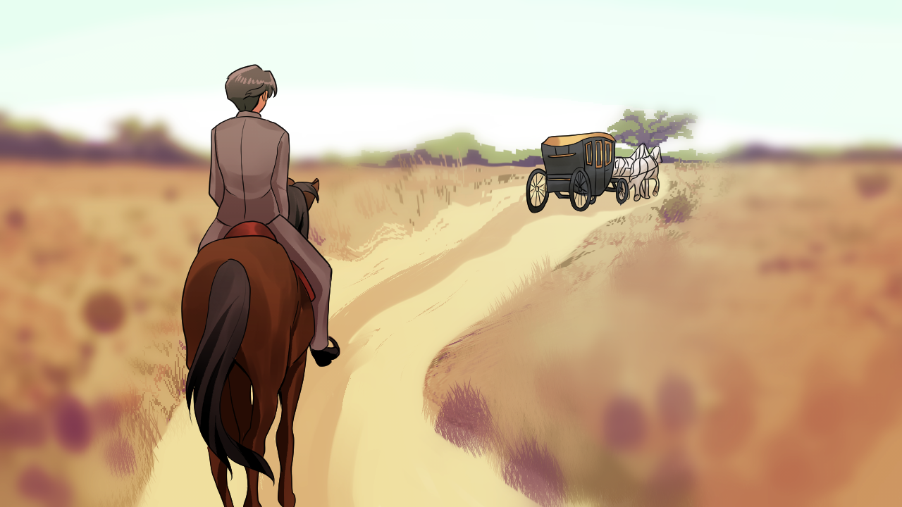

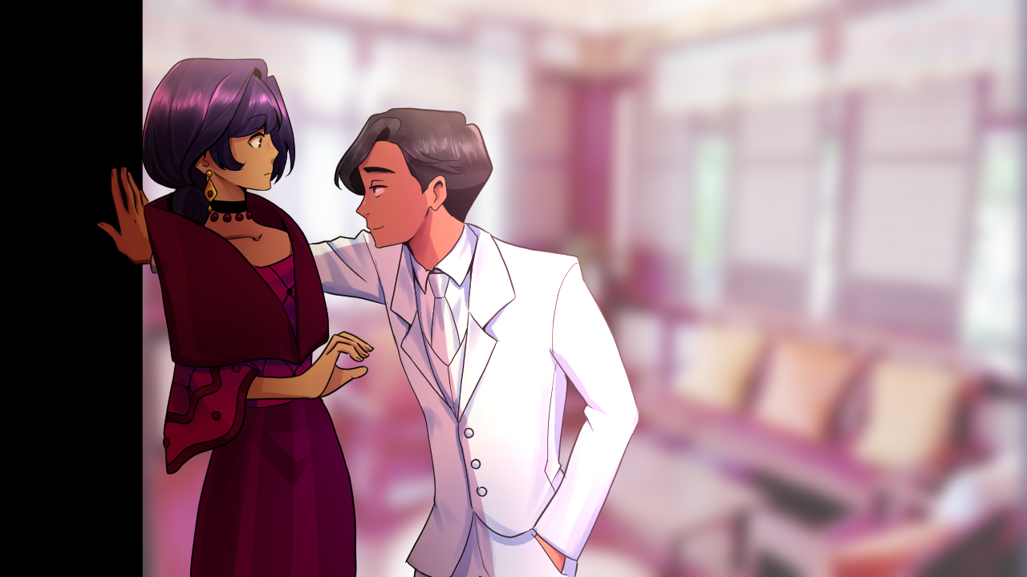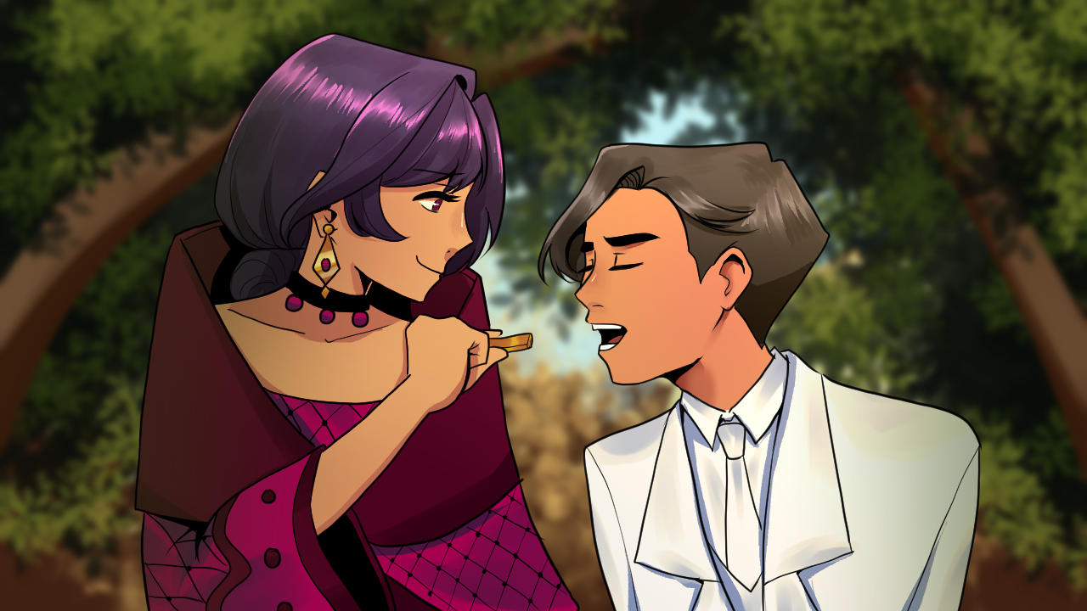

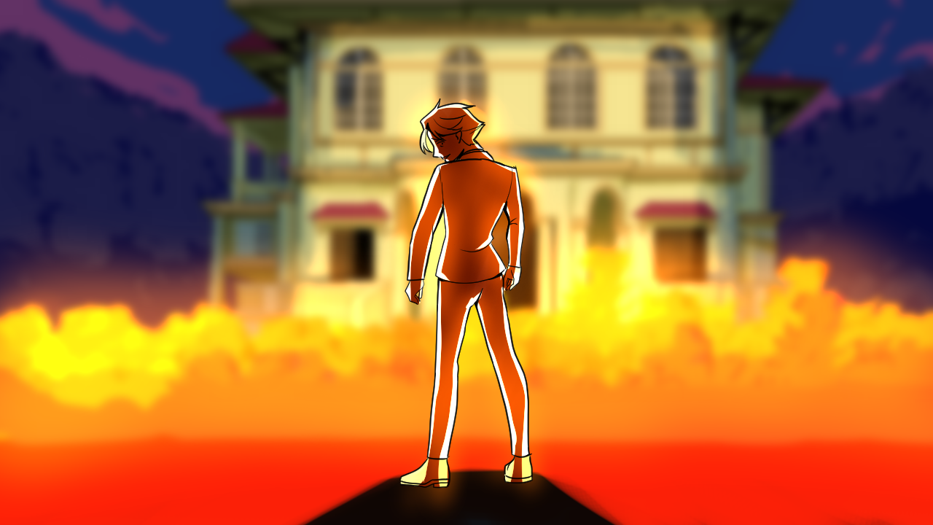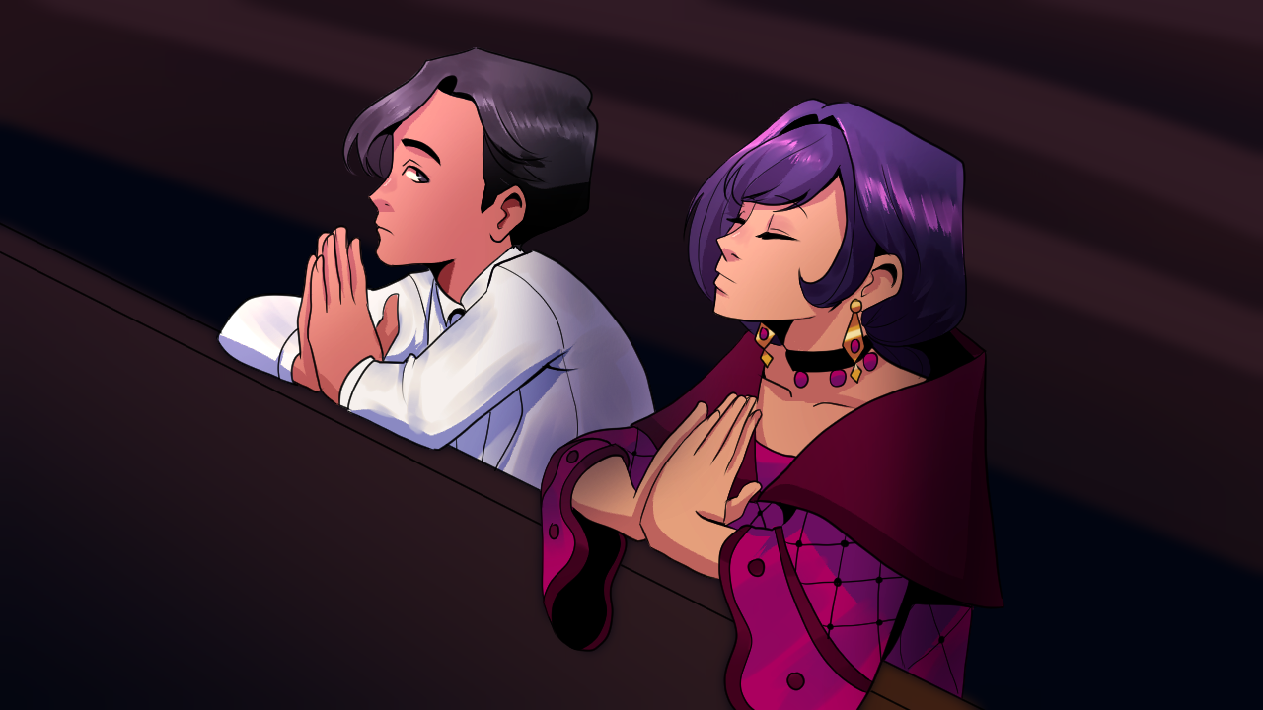

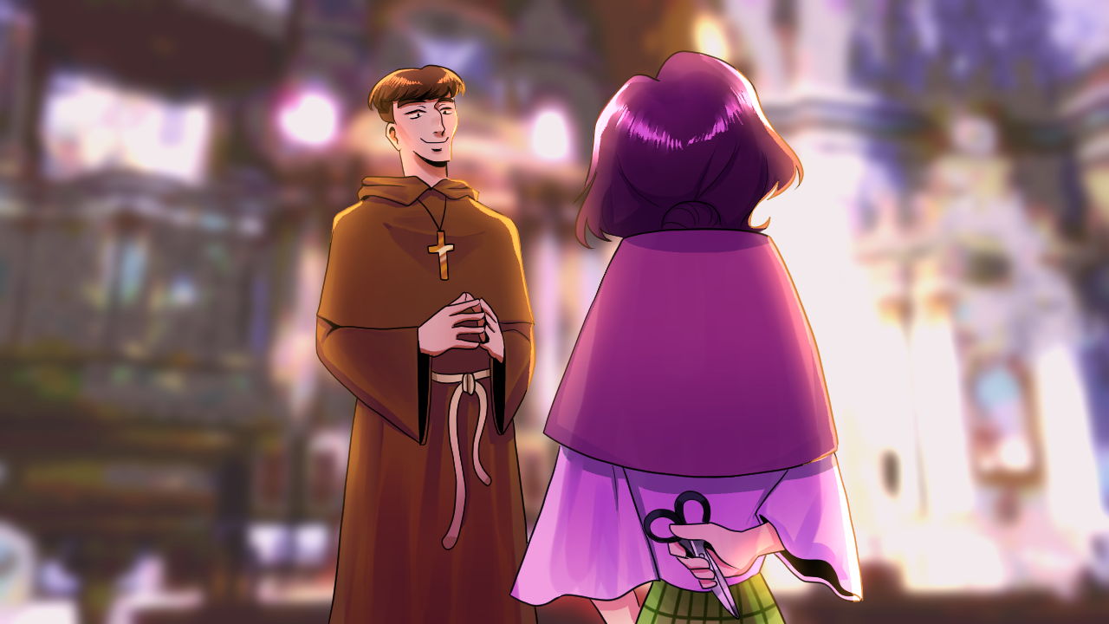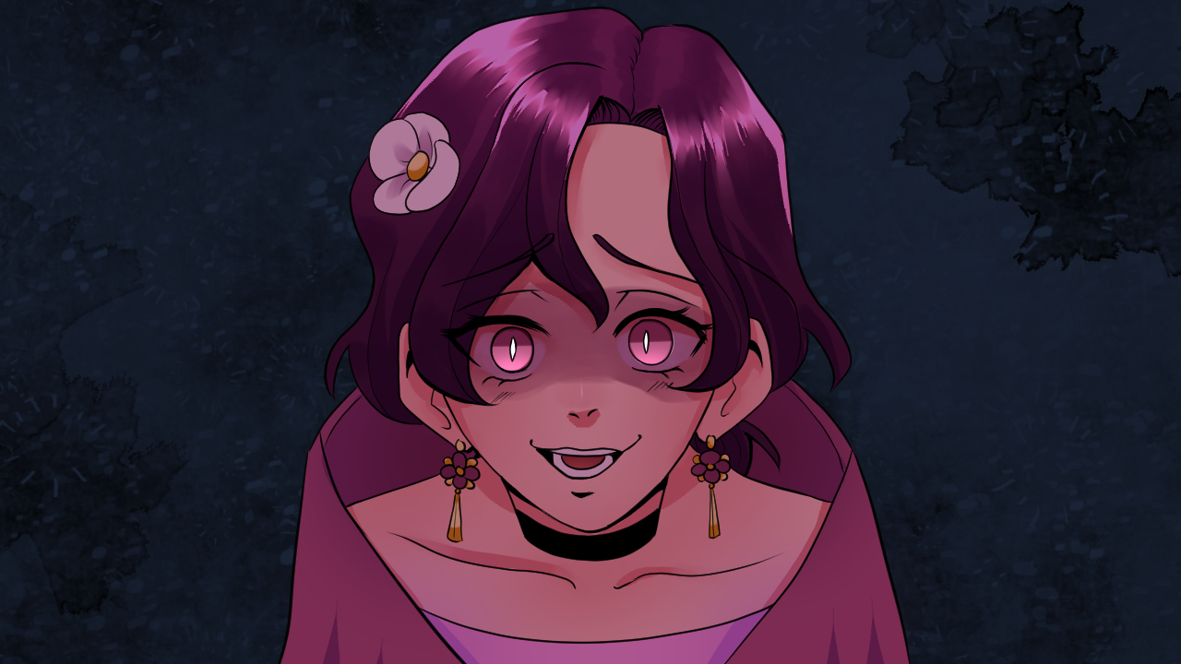

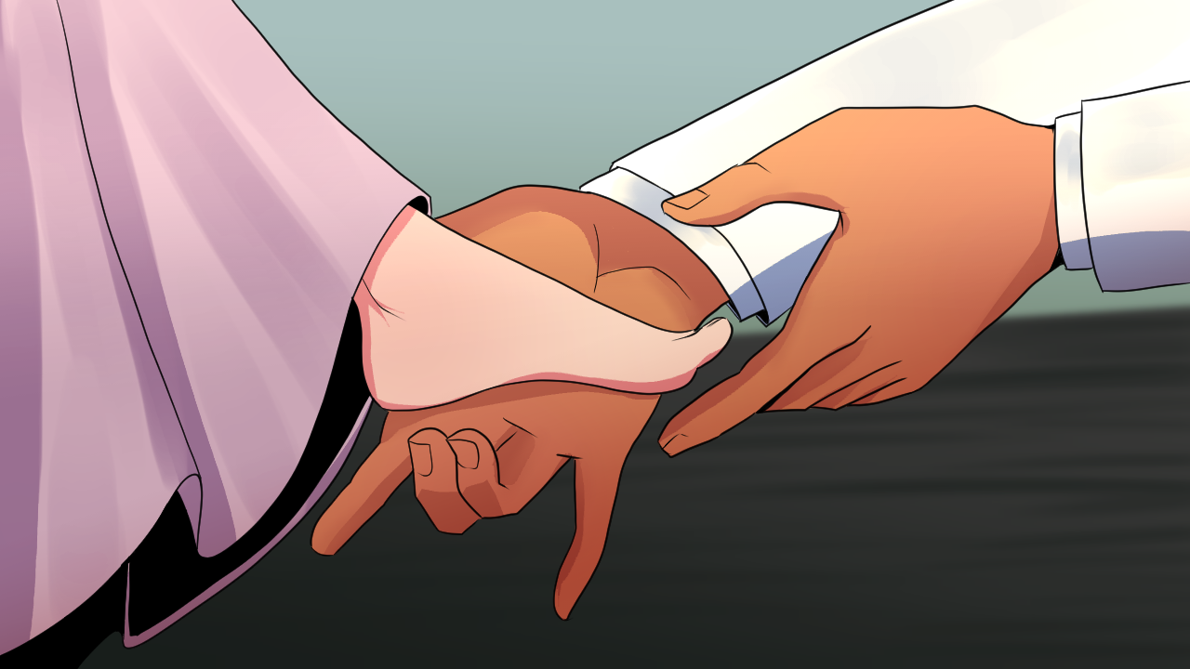

Appendix L

Character Design

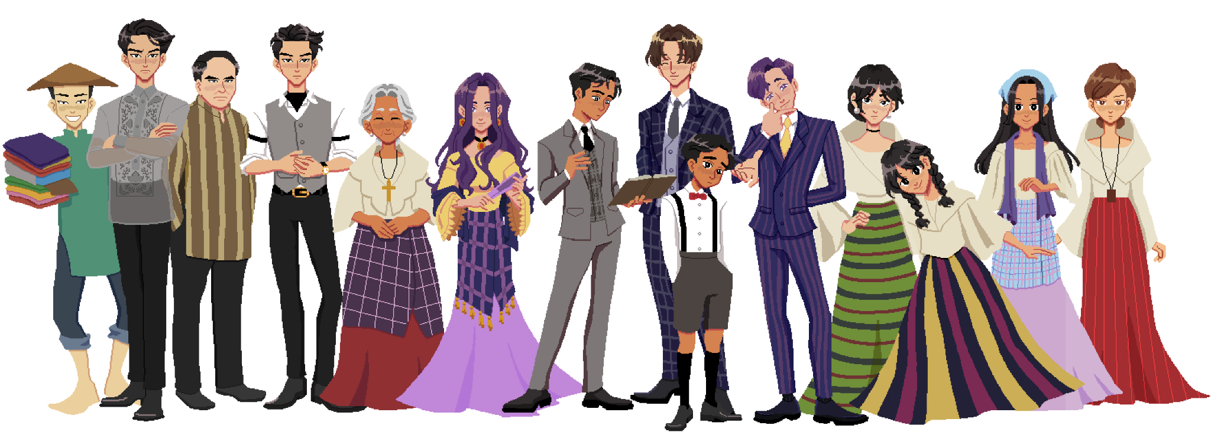

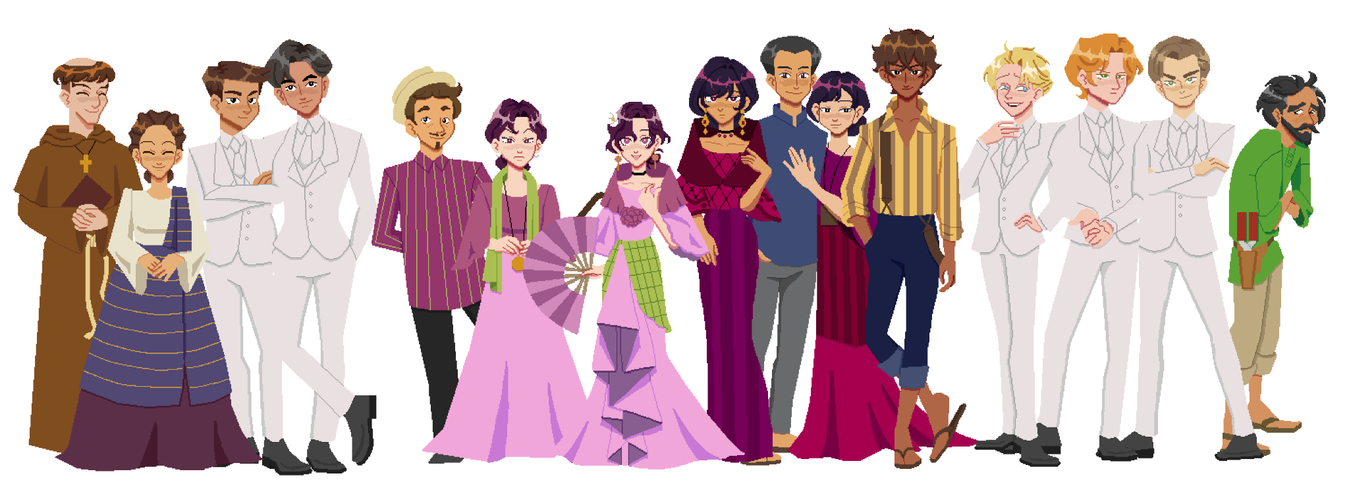

Appendix M

Disclaimer

This software project and its corresponding documentation entitled "Interactive Non-Linear Multi-branching Text-based Game on the Love Life of Jose Rizal Using Ren’Py Engine" is submitted to the College of Information and Communications Technology, West Visayas State University, in partial fulfillment of the requirements for the degree, Bachelor of Science in Entertainment and Multimedia Computing. It is the product of our own work, except where indicated text is.

We hereby grant the College of Information and Communications Technology permission to freely use, publish in local or international journals/conferences, reproduce, or distribute publicly the paper and electronic copies of this software project and its corresponding documentation in whole or in part, provided that we are acknowledged.

Jeff Giuseppe M. Ballais

Aimee Marie S. Barte

Jamie Ann L. Mediana

June 2023

Chrystal L. Mohsen Zaki

Ian A. Tacuyan